**Central Michigan University**

**BIS 698 Information System Project**

**Service Hub – Final Submission**

**Client –** **Handy Hive Technologies**

**Date – 04/29/2025**

**By**

**Group – 14**

**Vijay Kumar Balusa**

**Madhuri Kodiyalam**

**Ashwinkrishna Manickam Venkatasamy**

**Sruthi Masuram**

**Adithya Thirupathi**

**Tables of Contents:**

1. **Introduction**
2. **User Interfaces**
   1. **Home Page**
      1. **Steps to Run the Application**
   2. **Login and Registration**
      1. **Login Page**
      2. **Registration Page**
   3. **Customer Interface**
      1. **Service Provider Listings Page**
      2. **Provider Details Page**
      3. **Booking an Appointment**
      4. **Payment Page**
      5. **My Bookings Page**
         1. **View & Edit Bookings**
         2. **Post-Service Review**
      6. **Review Submission Page**
      7. **Manage Profile Page**
   4. **Service Provider Interface**
      1. **Provider Dashboard**
      2. **Manage Services Pop-Up**
   5. **Admin Interface**
      1. **Admin Dashboard Overview**
      2. **View All Bookings Pop-Up**

**2.6 About Page**

**Introduction:**

The Service Hub application has been strategically developed to bridge the longstanding gap between local service providers and customers by offering a centralized digital platform. Traditionally, individual service providers, including those offering carpentry, electrical, painting, and plumbing services, have operated without dedicated online representation. Service Hub addresses this challenge by enabling customers to seamlessly discover, connect with, and engage local service providers within their immediate locality.

The platform is designed to cater to three primary user groups: Customers, Service Providers, and admins.

Customers can search for service providers based on location and service type, securely book appointments, make online payments, and monitor the status of their service requests through a streamlined dashboard interface. Booking statuses are categorized as Pending, Started, or Completed, ensuring complete transparency throughout the service process.

Service Providers, through their dedicated dashboard, can efficiently manage their daily operations by viewing scheduled bookings, tracking upcoming appointments, adjusting service offerings, updating pricing structures, and managing their service availability to serve customer needs.

Administrators are equipped with a comprehensive oversight console to monitor overall platform activity, track total bookings, and analyze revenue generation trends through detailed graphical representations.

Through the implementation of Service Hub, we aim to not only enhance the accessibility of essential services for customers but also empower service providers with the digital tools necessary to grow and manage their businesses more effectively, thus creating a more connected and service-oriented community.

**Home Page:**

The Service Hub home page is the entry point for users looking to find trusted local service providers for various home services. The page features:

**Header:** Includes the Service Hub logo, navigation links (Home, About), and a Sign In button.

**Search Bar:** Allows users to search for specific services and their current city location is detected automatically also user can select their city.

**Popular Services:** Displays cards for common services such as Plumbing, Painting, Carpentry, and Electrical, each with a "Book Now" button.

**Footer:** Shows copyright and company information.

**Steps to Run the Service Hub Application:**

1. Prerequisites:
   * Node.js and npm are installed on your system.
   * Python and required backend dependencies (if running the backend).
   * The Service Hub project repository has been cloned to your local machine.
2. Start the Backend Server:
   * Open a terminal and navigate to the backend directory (e.g., servicehub-backend).
   * Create Virtual Environment: python -m venv venv
   * Activate the Virtual Environment: venv\Scripts\activate
   * Install Flask: pip install Flask
   * Install dependencies (if not already done): pip install -r requirements.txt
   * For creating automatically database: py create_db.py (make sure to create a schema in MySQL Workbench, ex: servicehub before running command)
   * Now start the server: py server.py
3. Start the Frontend Application:
   * Open a new terminal and navigate to the frontend directory.
   * Install dependencies (if not already done): npm install
   * Start the frontend development server: npm start
   * The frontend will run at http://localhost:3000/ by default.
4. View the Home Page:
   * Open your web browser and go to http://localhost:3000/.
   * You should see the Service Hub home page as shown in the screenshot below.

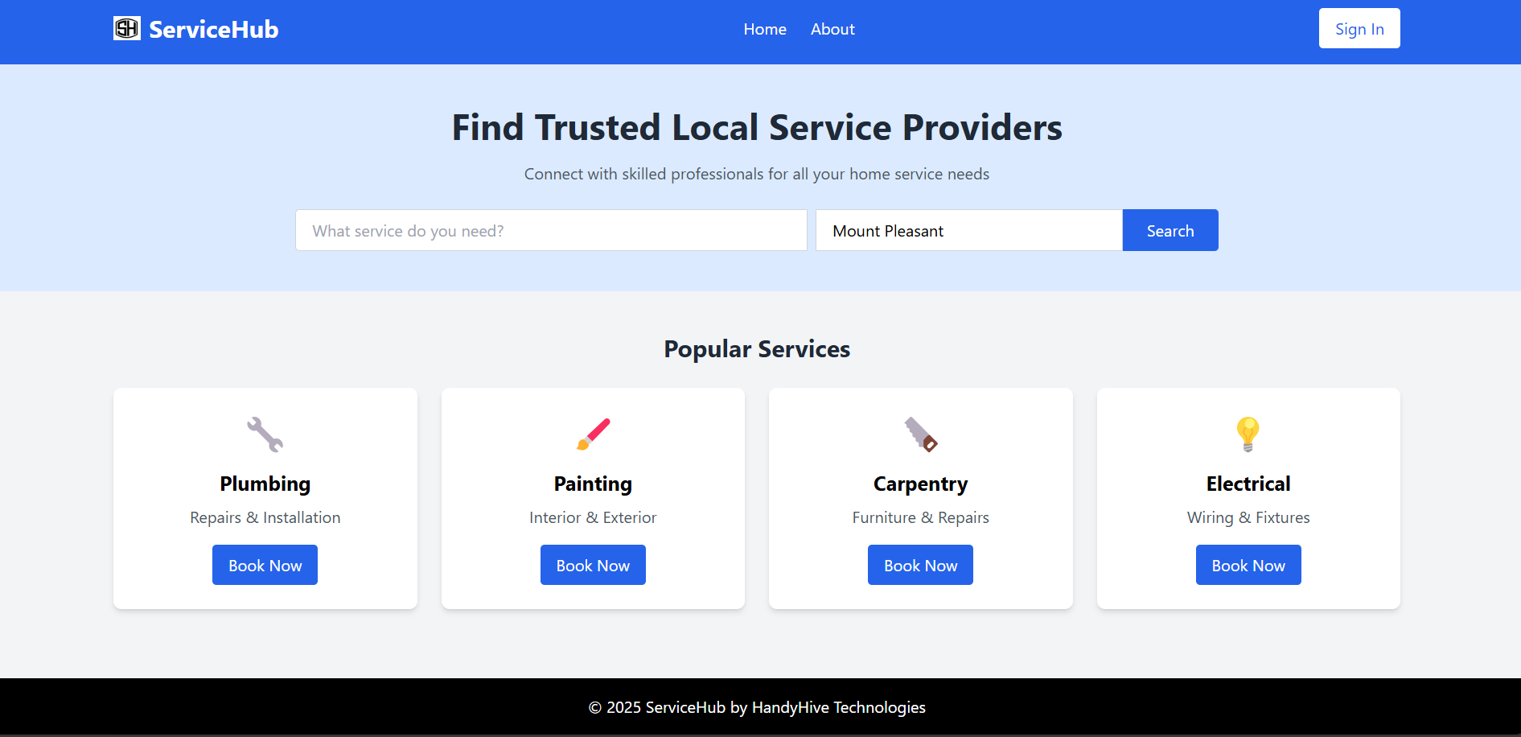

**Code:**

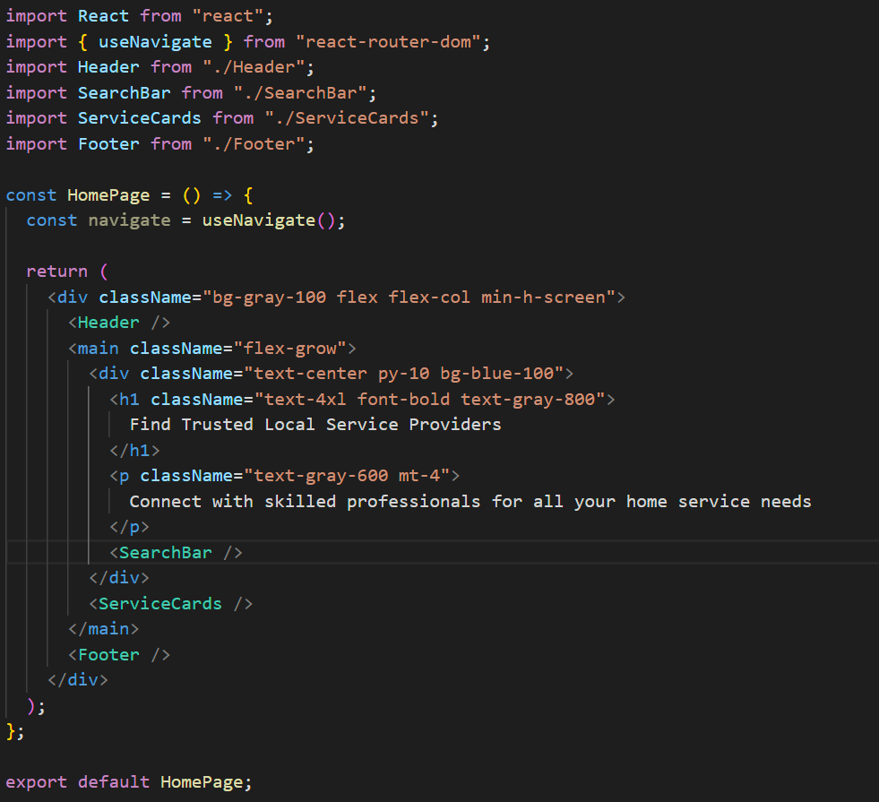

**Header Code:**

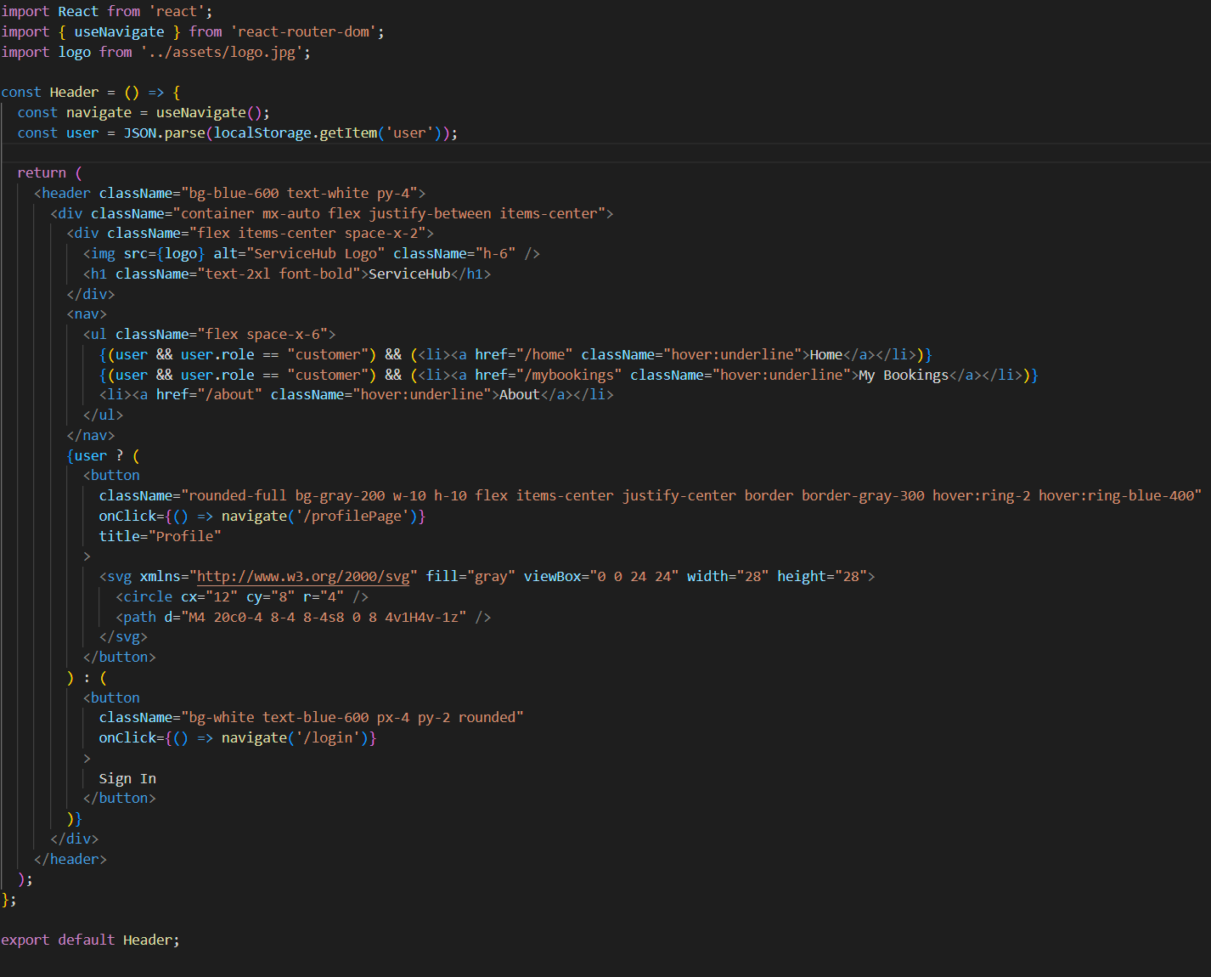

**Footer Code:**

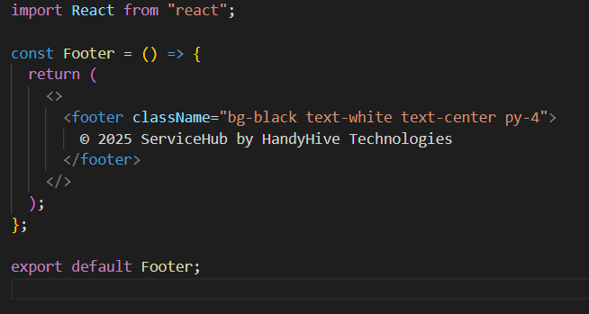

**Login Page:**

The login page provides a secure authentication interface for existing users to access the Service Hub platform.

Steps to the Login:

* Email – Enter the registered email ID of the user.
* Password – Enter the corresponding secure password.
* Click on the login button.
* If you do not have an account, click Sign up to go to the Registration page.

Features:

* Simple Form: Requires only email and password for authentication.
* Validation: Ensures both fields are filled before submission.
* Error Handling: Displays alerts for invalid credentials or if the user is not found.

Navigation:

Successful login redirects users based on their role:

* Customer: Redirected to the Home page.
* Provider: Redirected to the Provider Dashboard.
* Admin: Redirected to the Admin Dashboard.

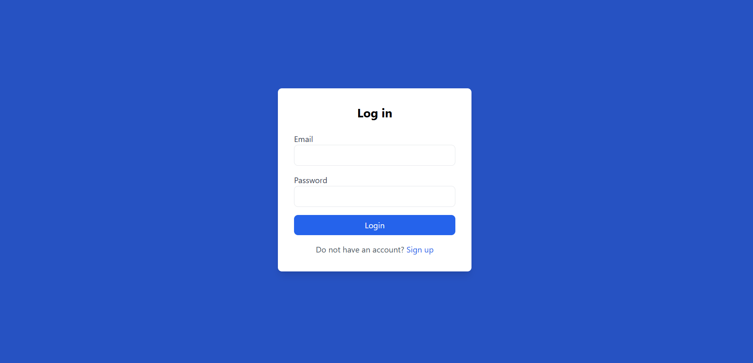

**Register:**

The Registration page enables new users to create a Service Hub account as either a Customer or a Service Provider.

Steps to register: The registration form includes the following mandatory fields

1. Fill in your first and last name.
2. Enter your email. (example: john.doe@email.com)
3. Create a password. (Format: Minimum any 6 characters hidden input for safety)
4. Select your role (Customer or Service Provider).
5. Enter your address (use autocomplete for faster entry).
6. Fill in your phone number (example: 989-989-9898), city, state, and zip code.
7. (Providers only) Enter your company name and a brief description.
8. Click Register to create your account.
9. After successful registration, log in with your new credentials.

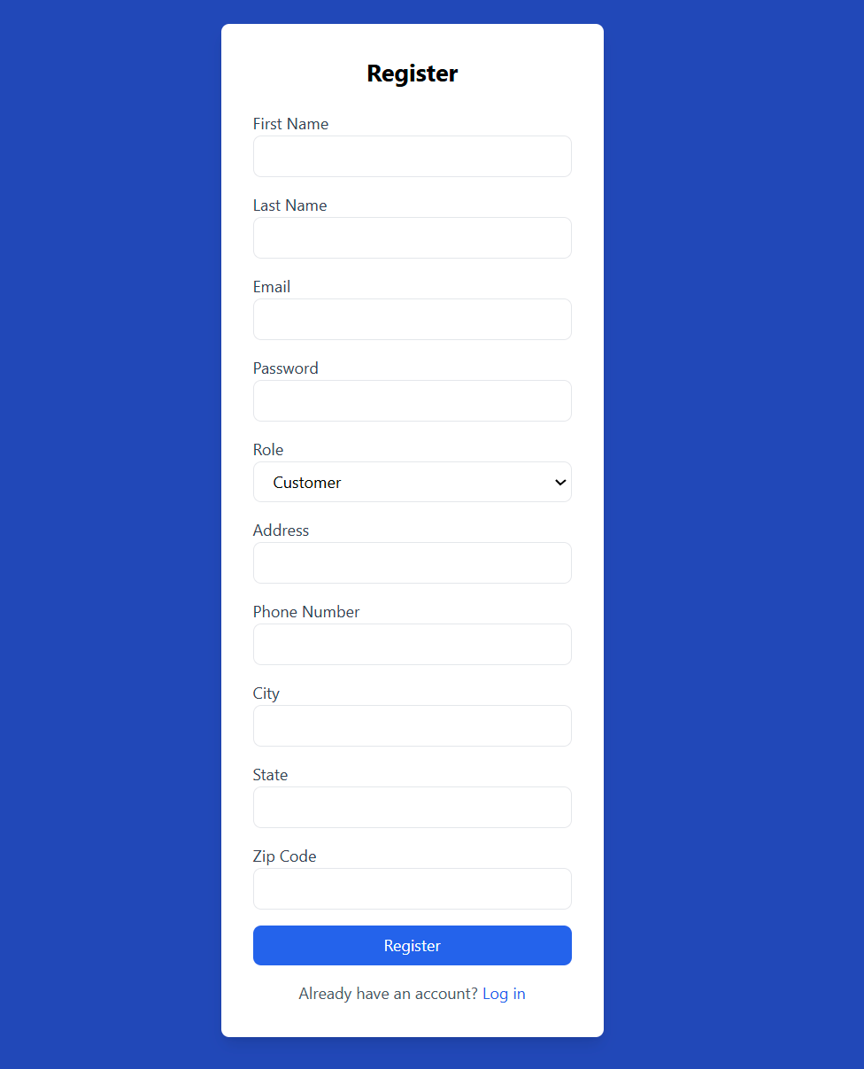

**Code:**

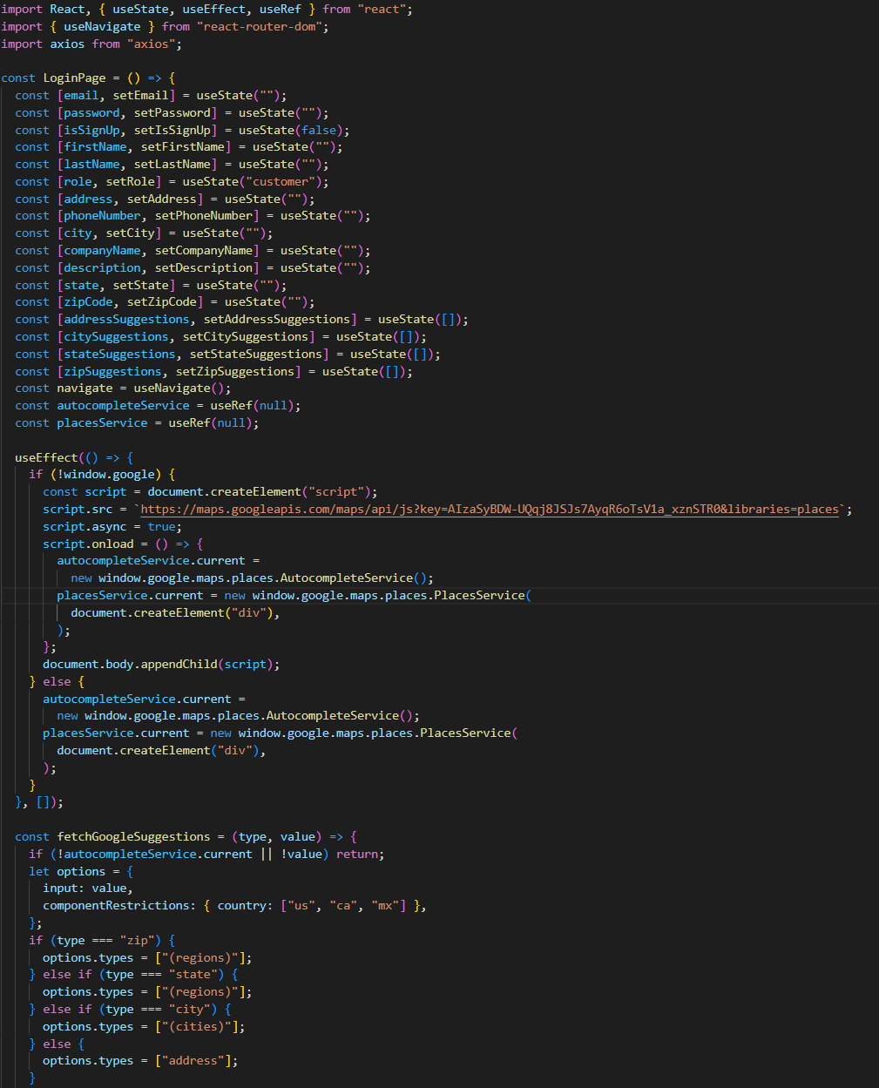

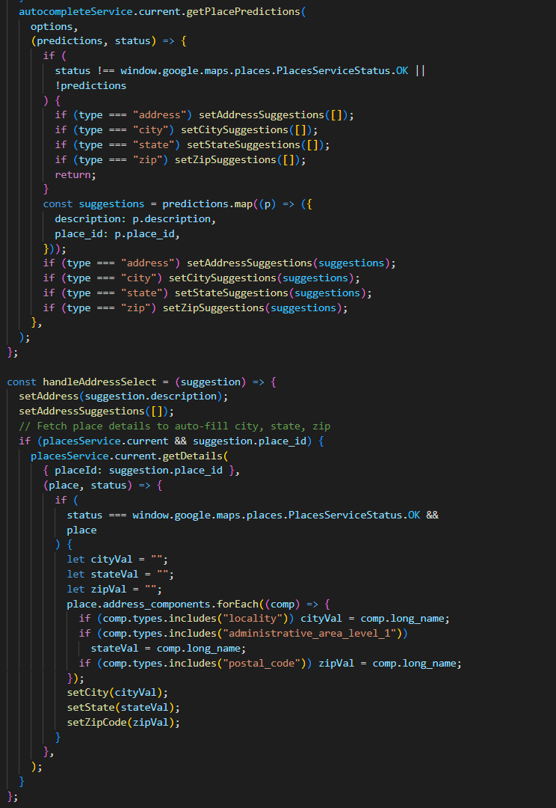

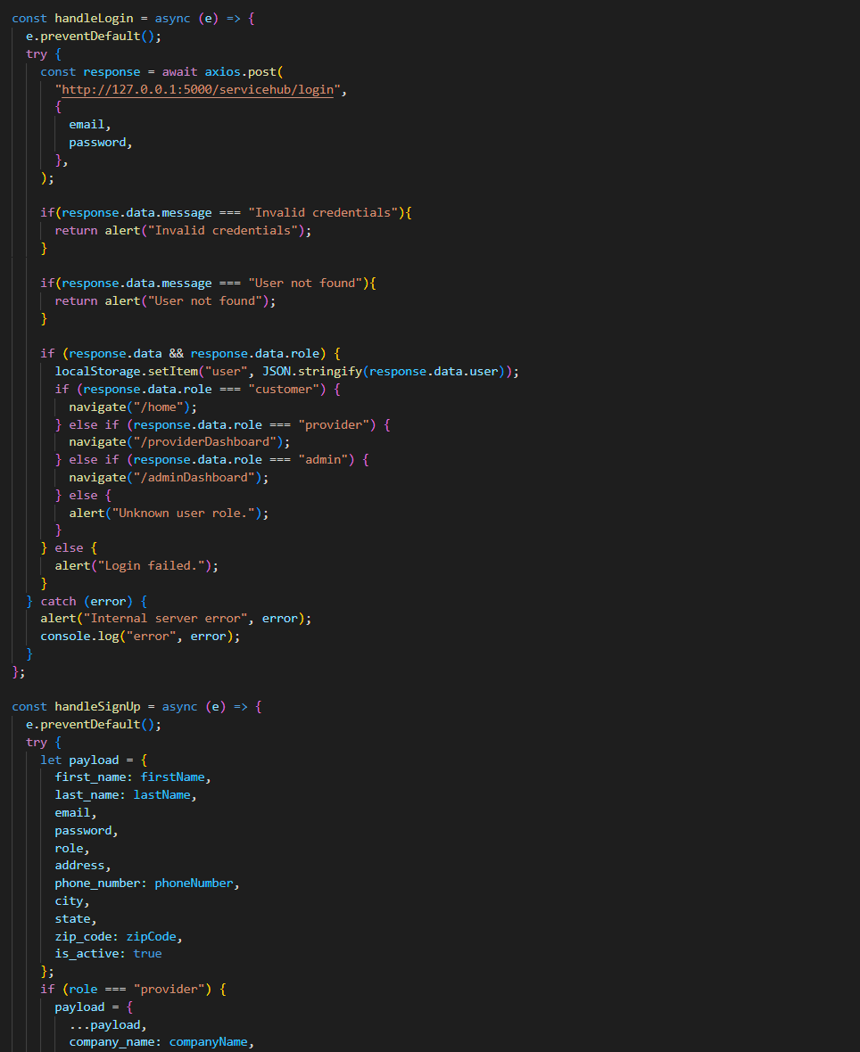

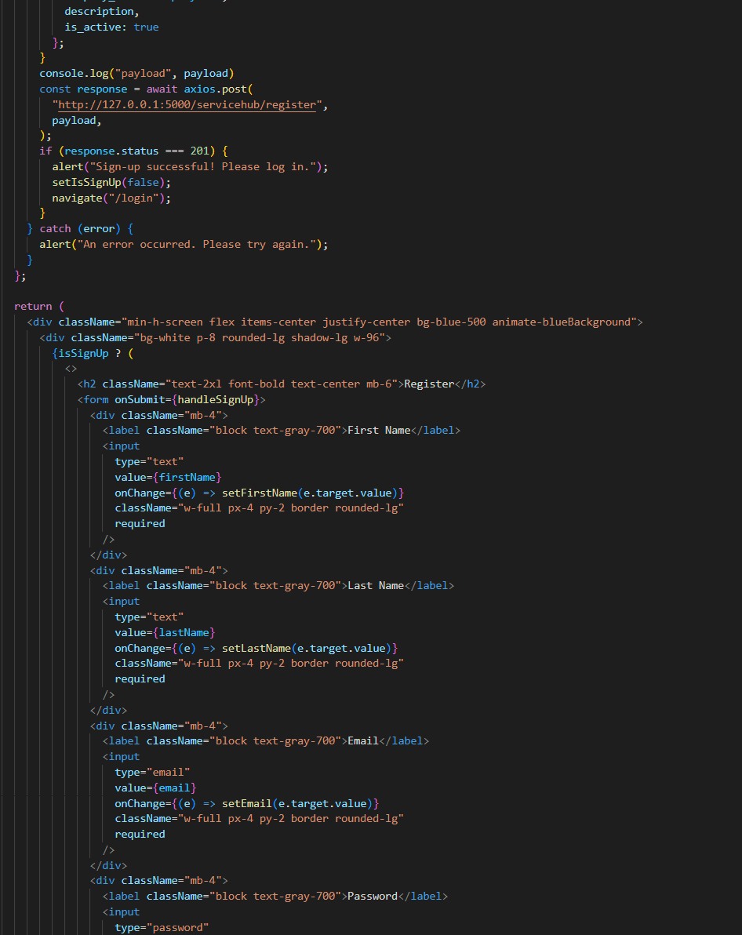

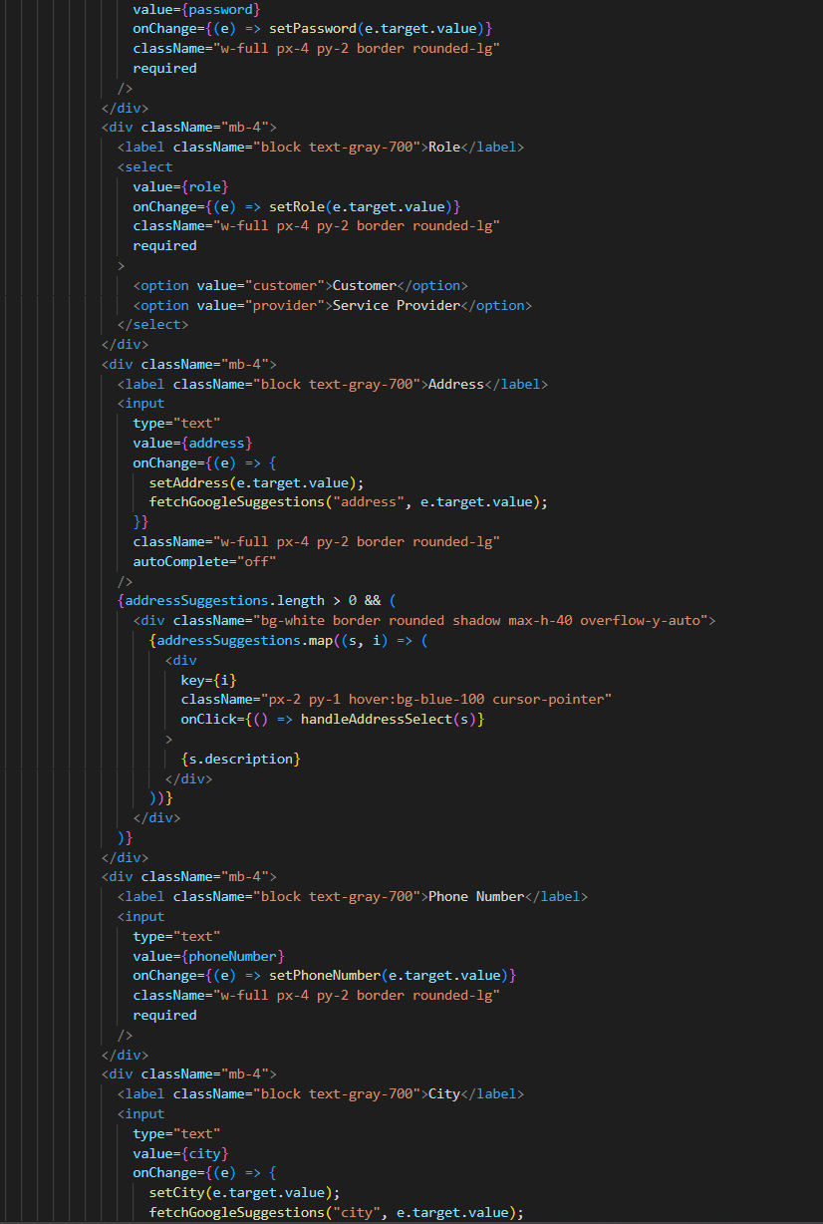

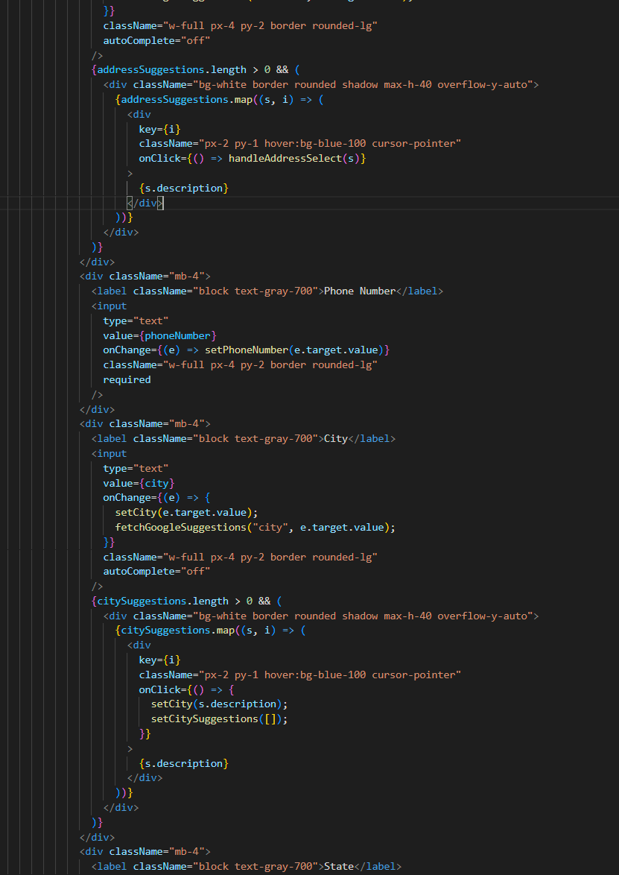

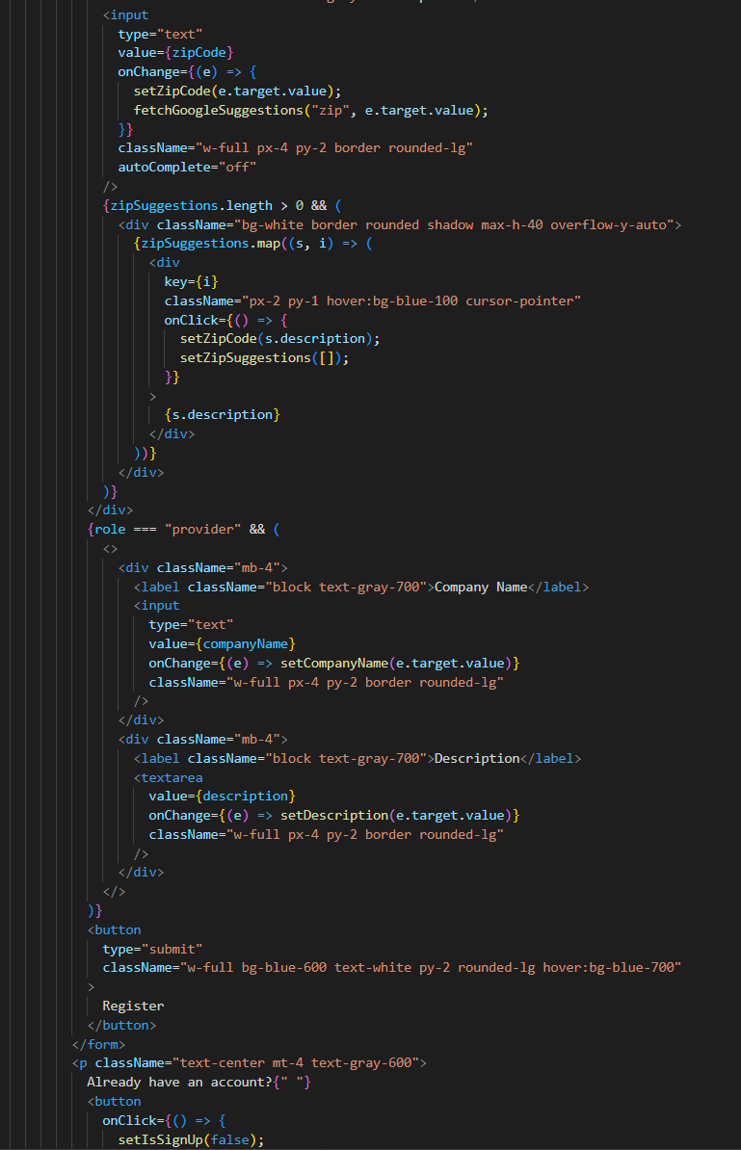

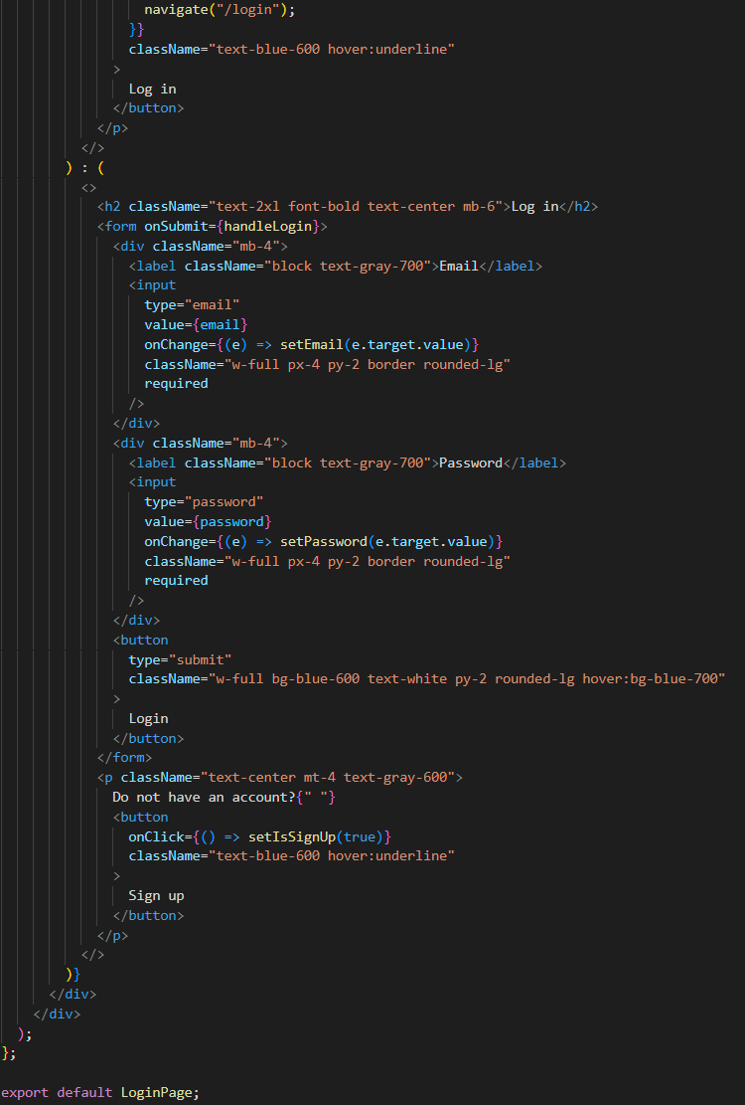

**Customer Interface**

**Service Provider Page:**

After a successful login, users are redirected to the Home Page. When they click the Book Now button for a selected service (e.g., Plumbing or Painting), the system displays a list of service providers available in the user's chosen locality.

On the Service Providers Page, each provider is shown in a clean card layout with the following details:

* Provider Name (e.g., Leah)
* Type of Service (e.g., Plumbing)
* Average Customer Rating
* After clicking on the view details button, to user can see more information, such as services offered, availability, and booking options

This page helps users easily find and choose reliable service providers in their area.

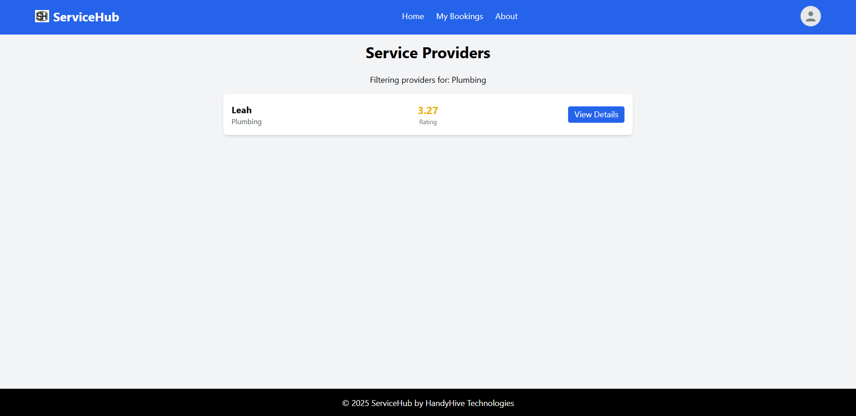

**Service Provider Details Page:**

This page displays key information about a selected service provider, including services offered, pricing, reviews, and availability. It helps users make informed decisions before booking an appointment.

Steps to Use the Provider Details Page:

1. Review Provider Overview
   * Check the provider’s name, rating, reviews, and location at the top of the page.
   * Confirm their availability status.
2. Explore Offered Services
   * Under the Services tab, view the list of available services along with their prices.
3. Read Reviews and About Section
   * Switch to the Reviews tab to see customer feedback.
   * Use the About tab to learn more about the provider.
4. Book an Appointment
   * Click the Book Appointment button to begin the service booking process.

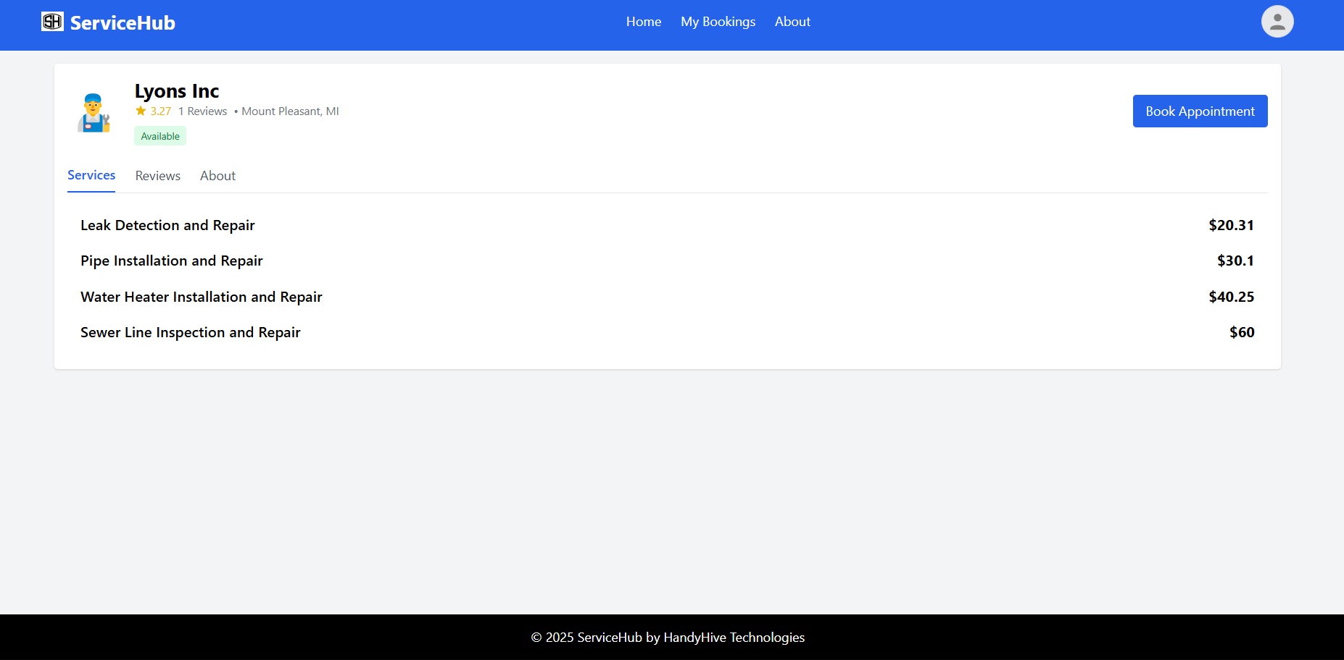

**Code:**

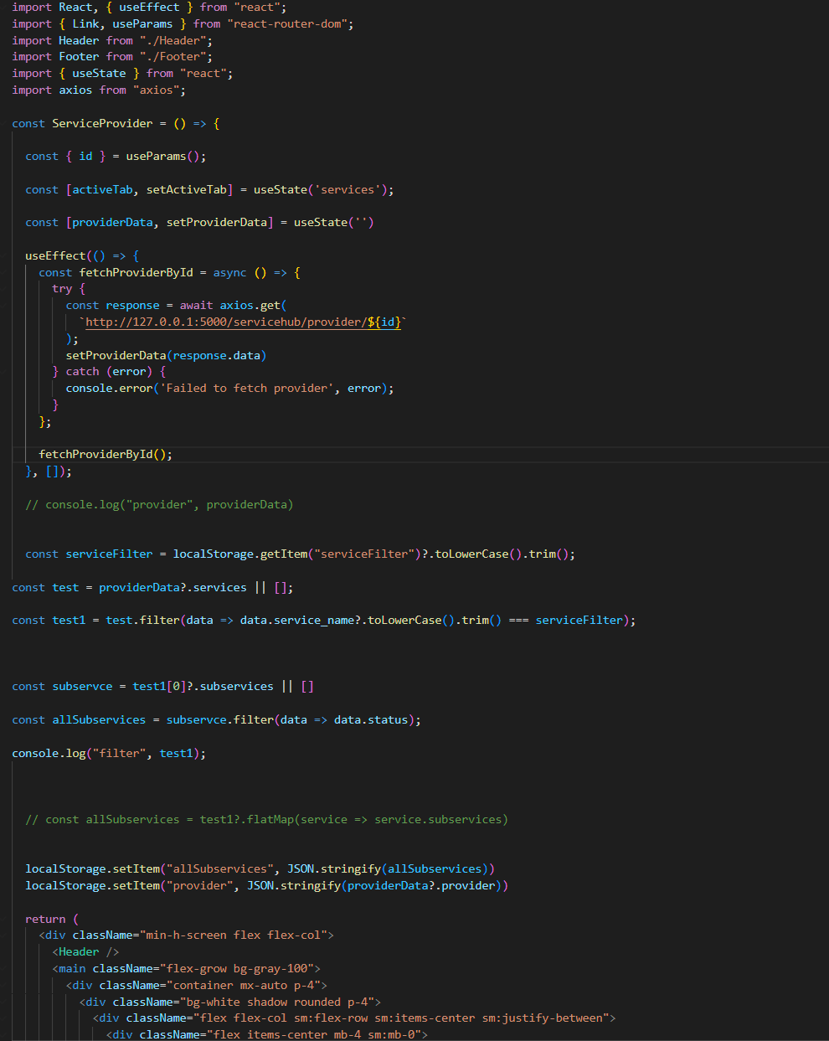

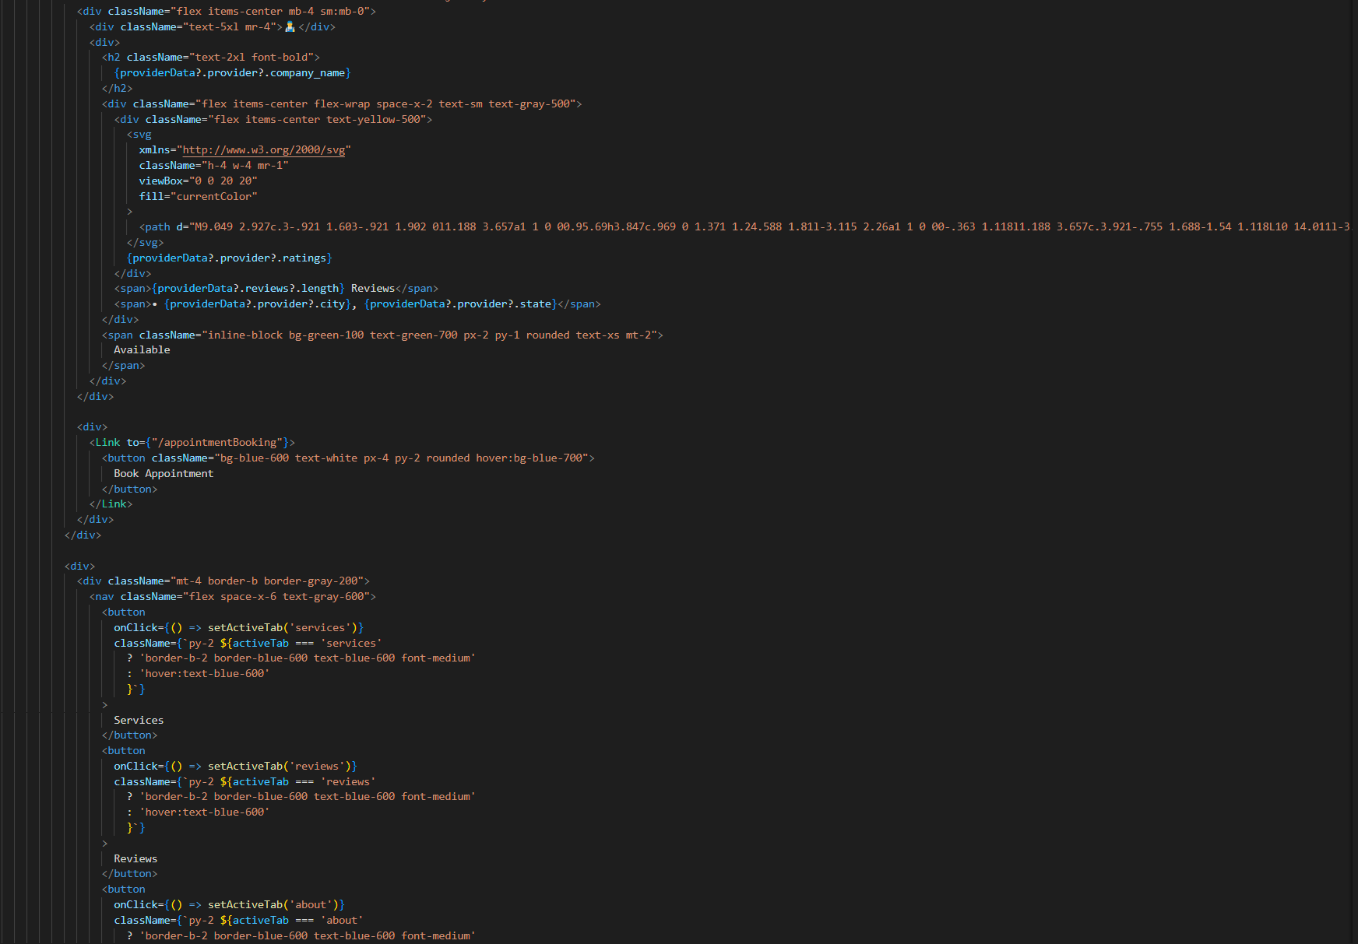

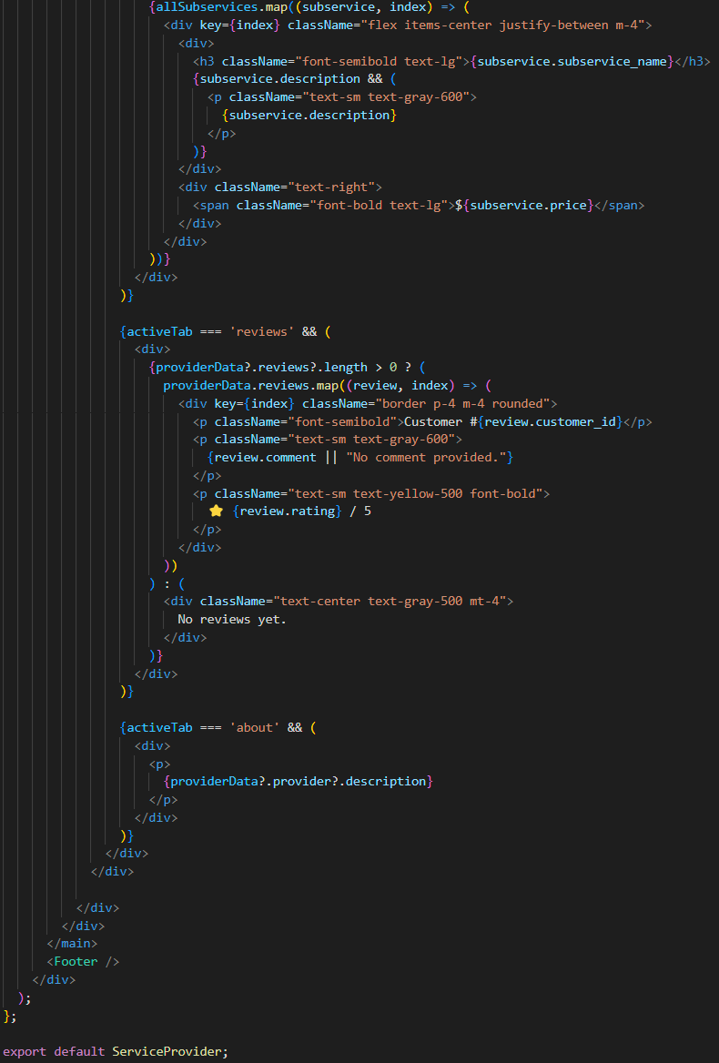

**Appointments Page:**

The Book an Appointment page allows users to easily schedule a service with a selected provider. Users can choose the service, select a date and time, enter their address, and add any special instructions. This page ensures all necessary details are captured for a smooth and successful booking.

1. Select Service:
   * Field: Service
     1. Required: Yes
     2. Example: Leak Detection and Repair
     3. Note: Select from the dropdown list of available services.
2. Pick Date and Time:
   * Field: Date
     1. Required: Yes
     2. Example: 04/29/2025
     3. Note: Use the date picker (past dates cannot be selected).
   * Field: Time
     1. Required: Yes
     2. Example: 10:30 AM
     3. Note: Choose from predefined time slots.
3. Enter Address Details:
   * Field: Address
     1. Required: Yes
     2. Example: 123 Main S
     3. Note: Street address (manual entry).
   * Field: City
     1. Required: Yes
     2. Example: Mount Pleasant
     3. Note: Auto-filled or manual entry.
4. Add Additional Notes (Optional):
   * Field: Additional Notes
     1. Required: No
     2. Example: Please call on arrival.
     3. Note: Add any special instructions or requests for the provider.
5. Review Booking Summary:
   * Confirm service details in the summary card, including:
     1. Service Name
     2. Date and Time
     3. Service Fee
6. Book Appointment:
   * Click the Book Now button to finalize and confirm the appointment.

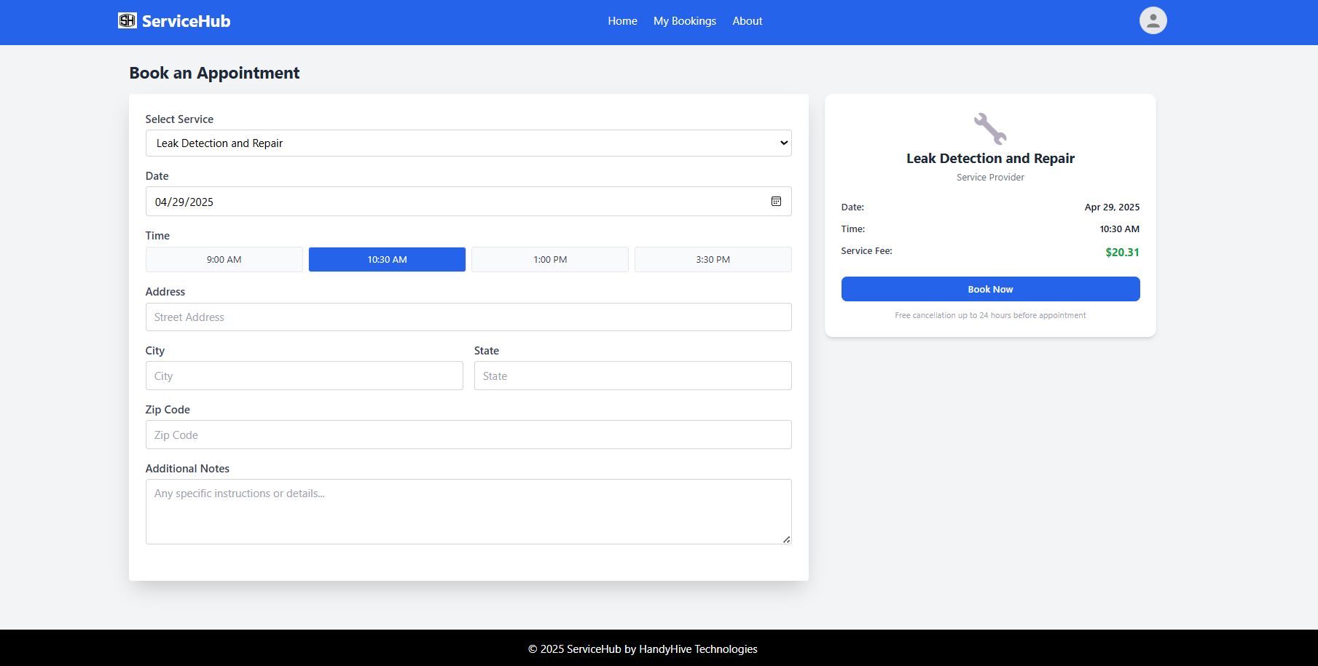

**Code:**

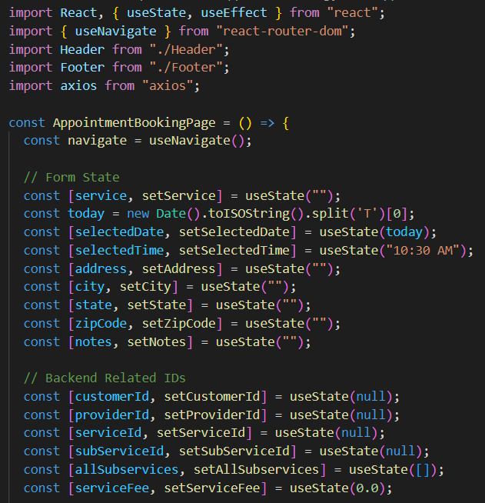

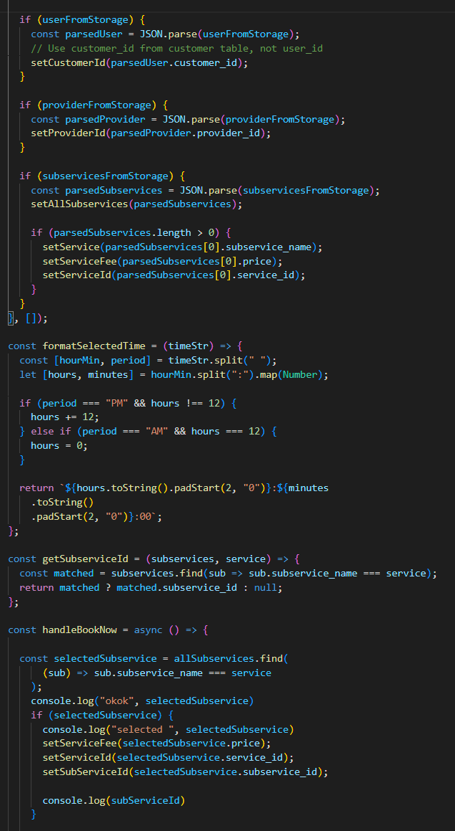

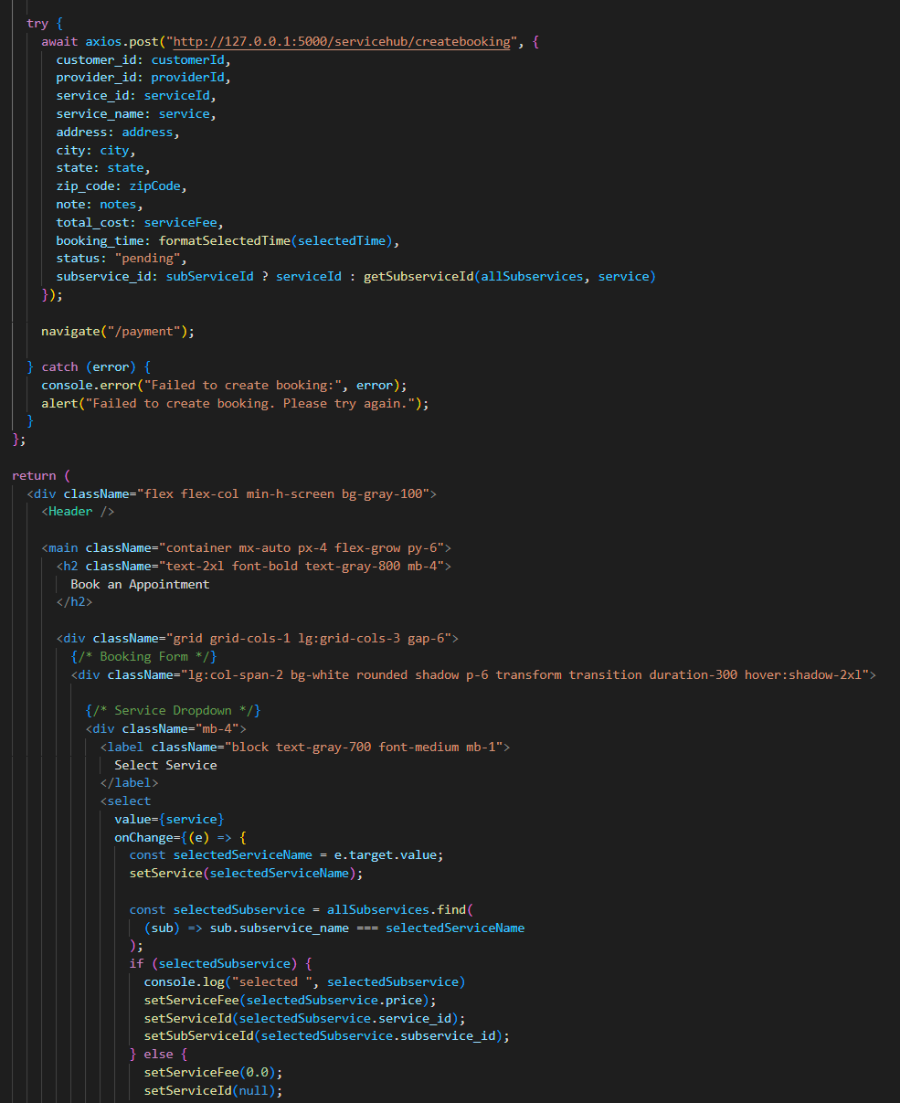

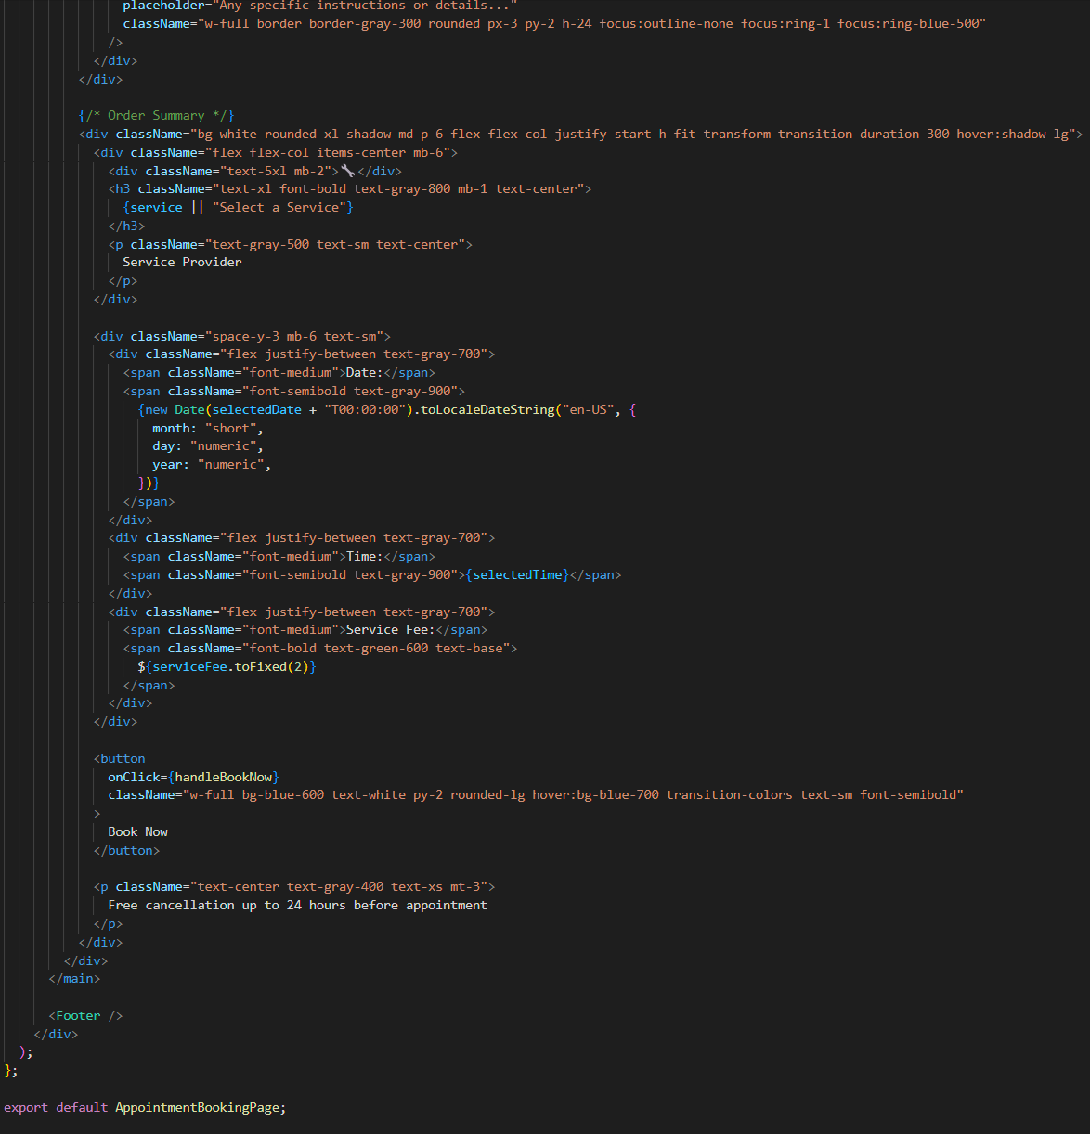

**Payments Page:**

The Payment Details page is the final step in completing a service booking on the Service Hub platform. This page collects the user’s payment information and billing details to process the transaction.

Steps to Use the Payment Details Page

1. Enter Card Information:
   * Input your Card Number, Expiration Date, and CVV.
   * Ensure that the format is correct to see the fields turn green; invalid entries will turn red.
2. Fill in Billing Address:
   * Provide your Street Address, City, and Zip Code.
   * Fields will also show green for valid entries and red for any formatting issues.
3. Complete the Payment:
   * Click the Pay Now button to securely process your payment and confirm the service booking.

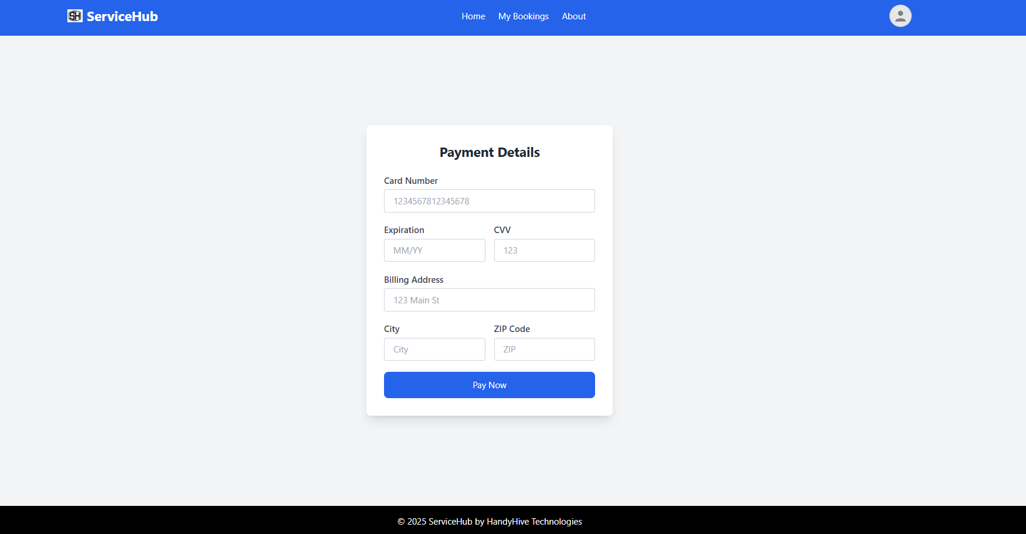

**Code:**

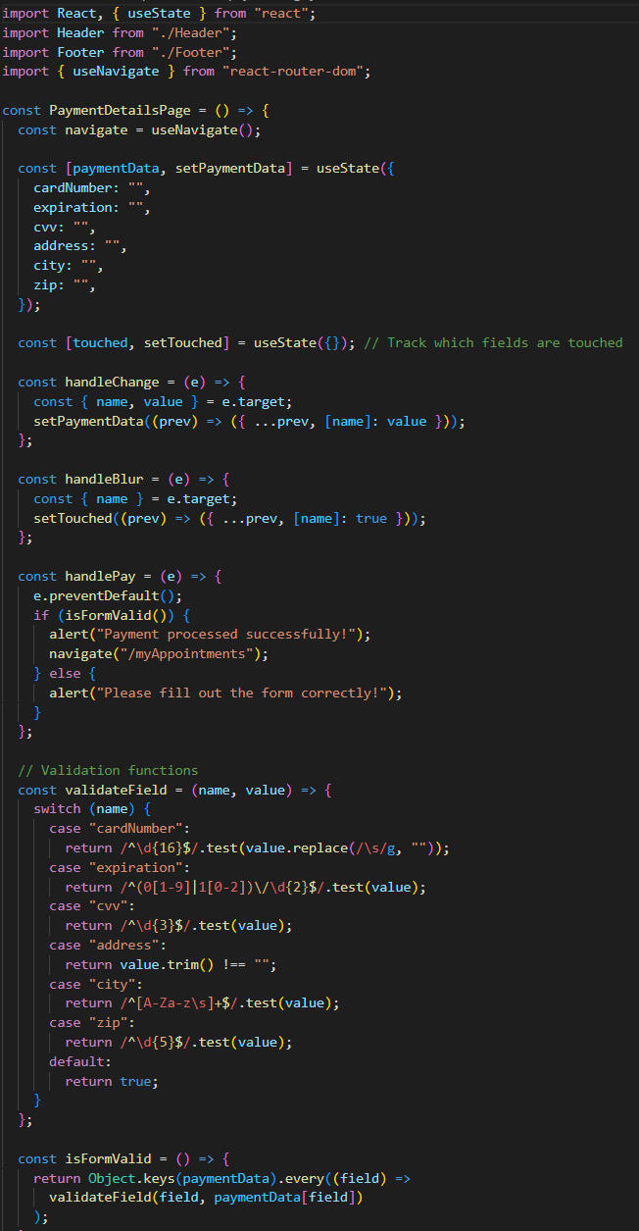

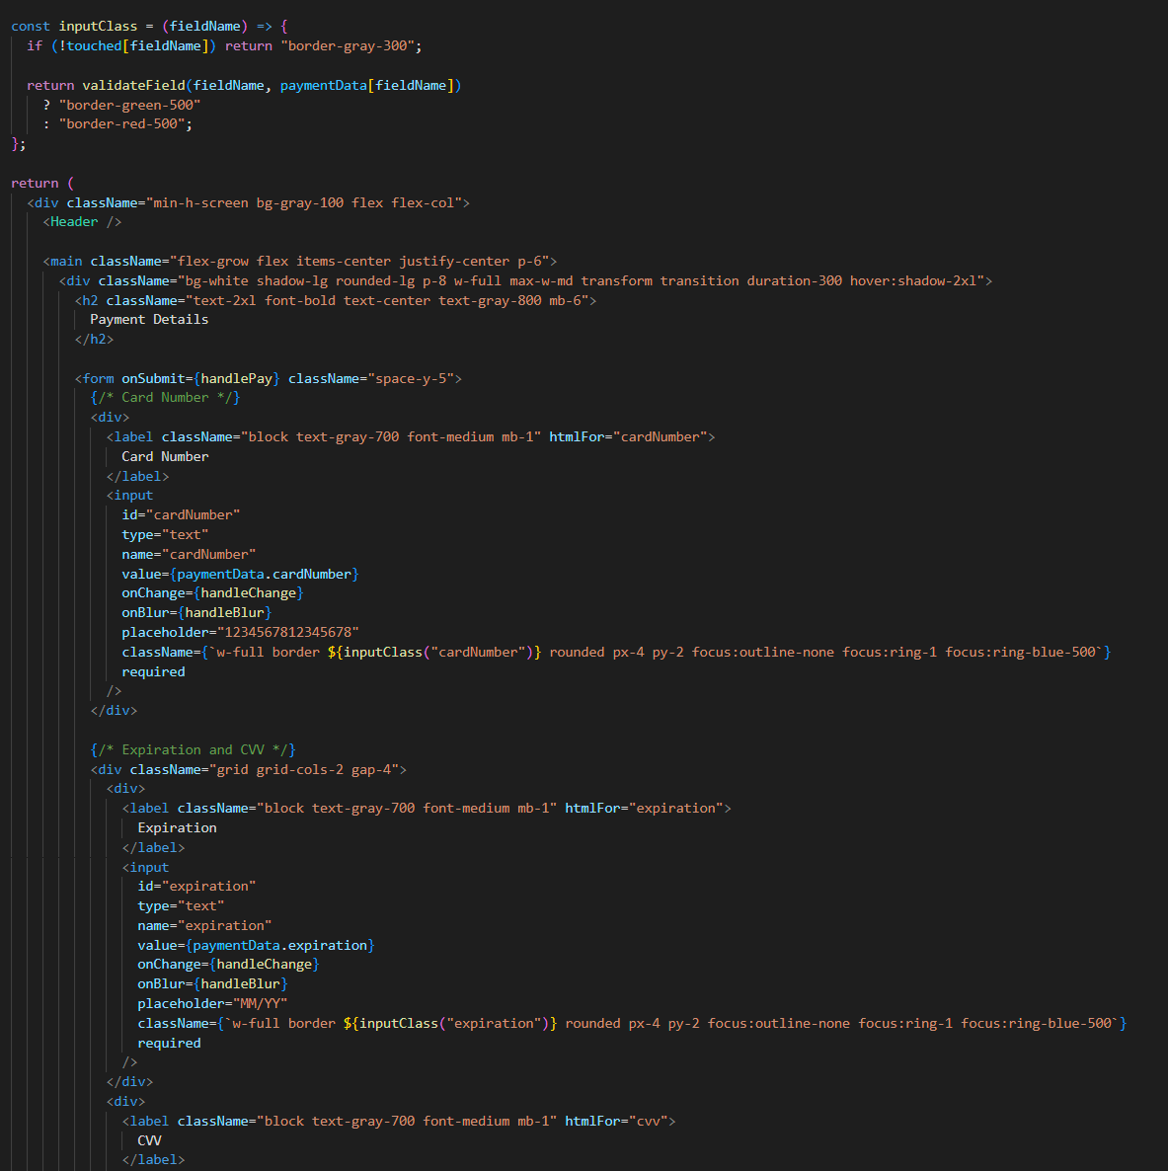

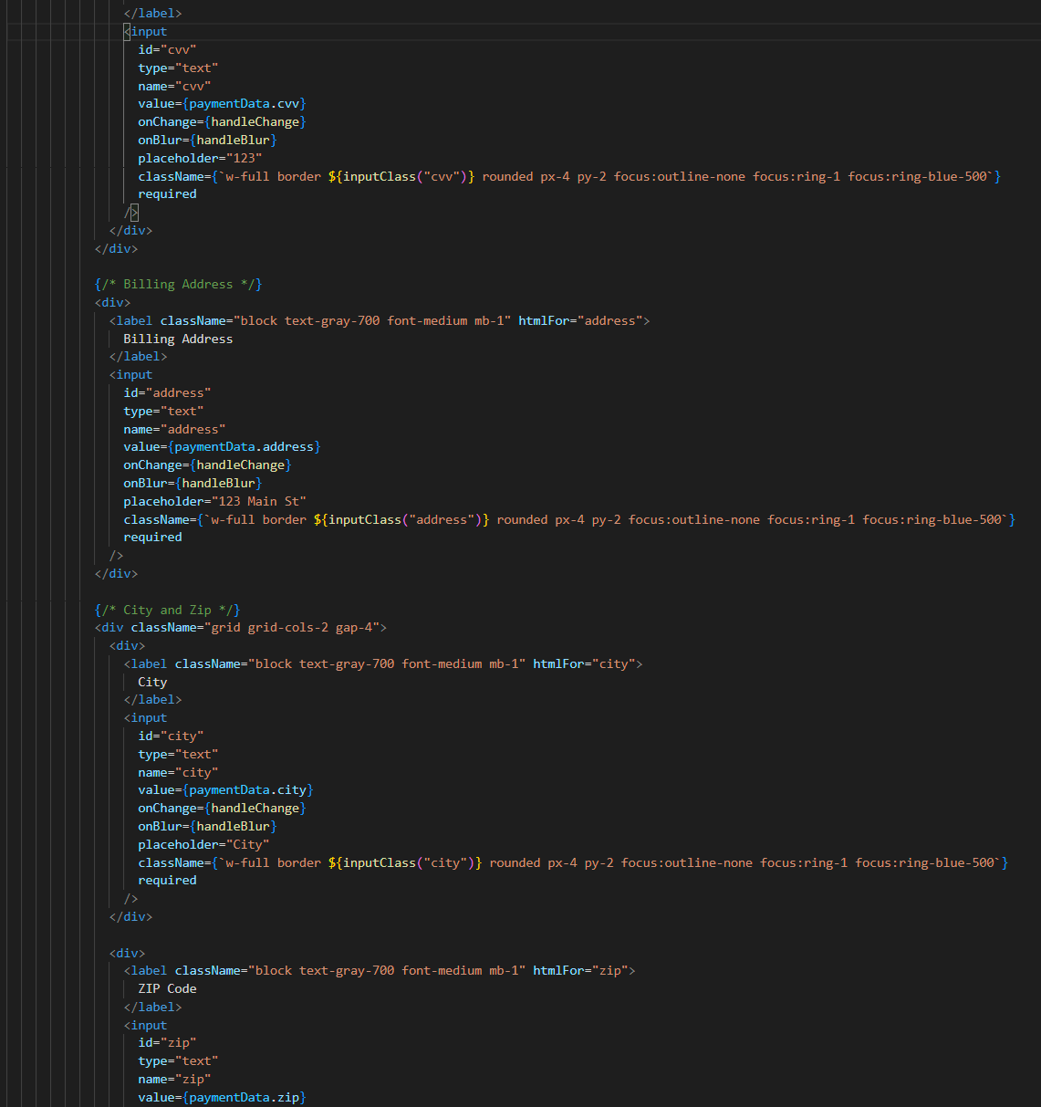

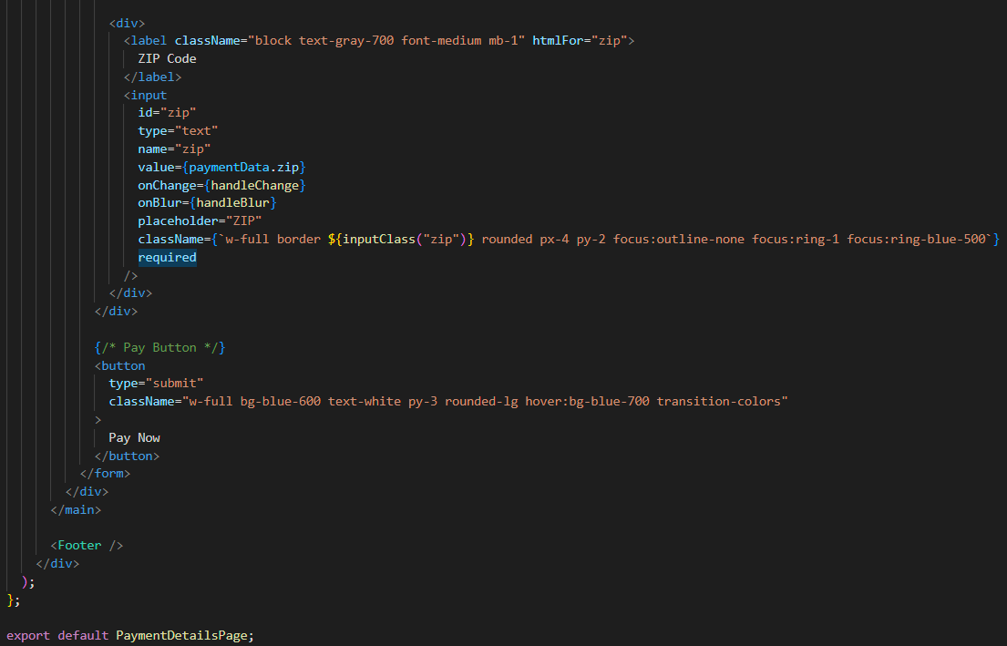

**My Bookings Page:**

The My Bookings page provides users with a centralized view of all their scheduled services, along with real-time status updates that can be viewed by the customer.

**Steps to Use the My Bookings Page:**

1. Review All Bookings
   * Scroll through the list to view scheduled appointments and their current statuses.
2. Check Status Labels
   * Quickly identify the progress of each booking via color-coded tags (e.g., pending, commented, completed).
3. View Booking Details
   * Click the View Details button on any card to access full service information and update it.

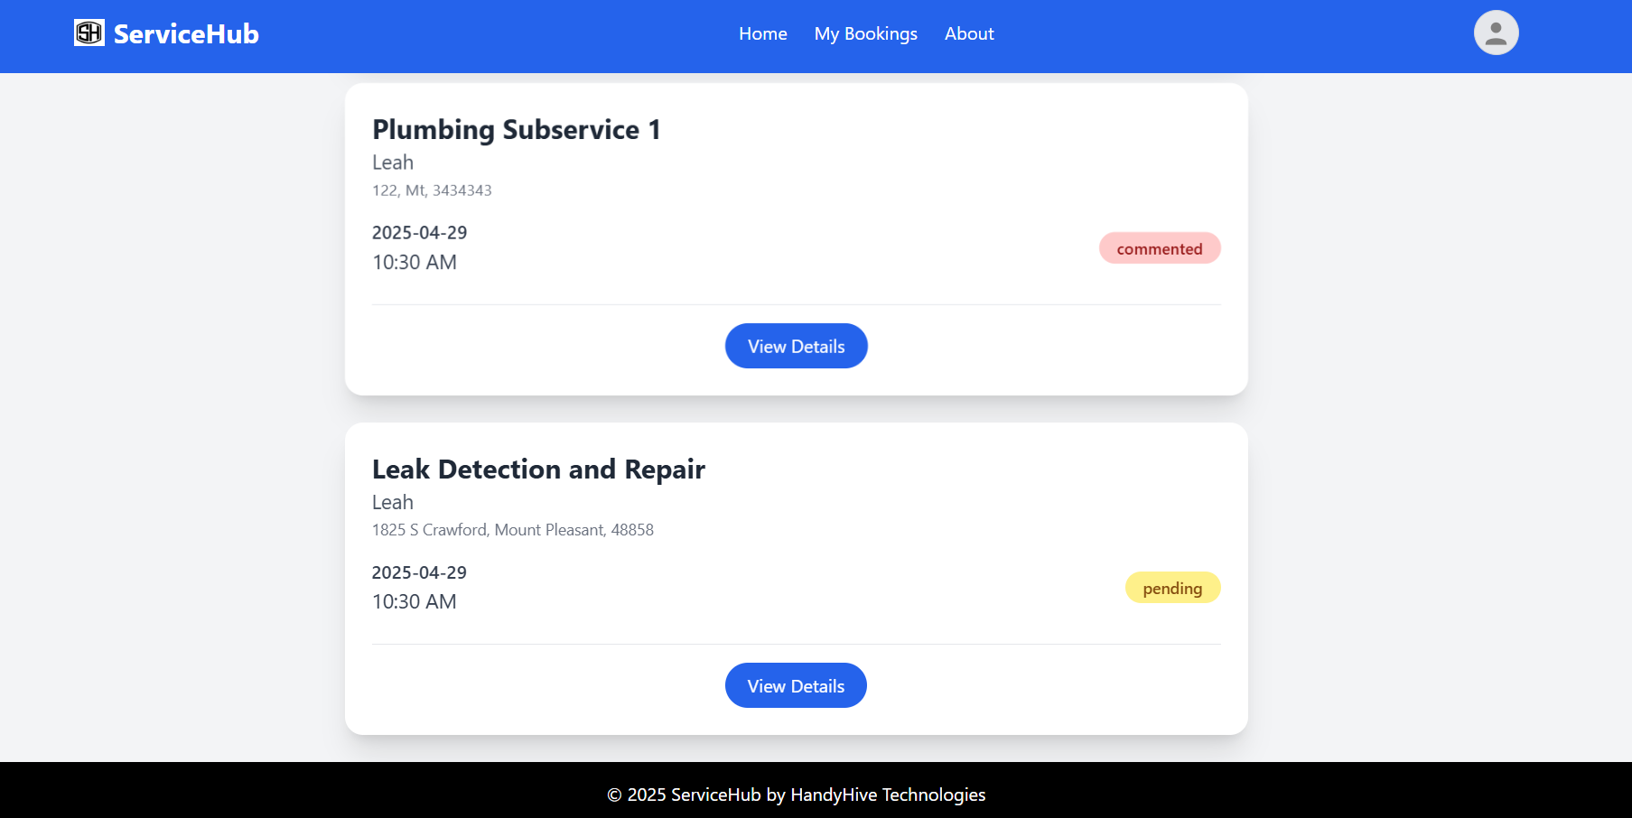

**Edit Bookings:**

When a user clicks on the View Details button, it opens the Edit Booking page and enables users to update appointment details before service delivery. This feature provides flexibility in managing scheduled services efficiently.

Steps to Use the Edit Booking Page:

1. Modify Appointment Details:
   * Update any necessary fields, including service type, time slot, or address information.
2. Review the Summary:
   * Cross-check the updated details in the summary panel on the right.
3. Save or Cancel:
   * Click Save Changes to confirm and apply the edits.
   * Click Close to exit without saving.

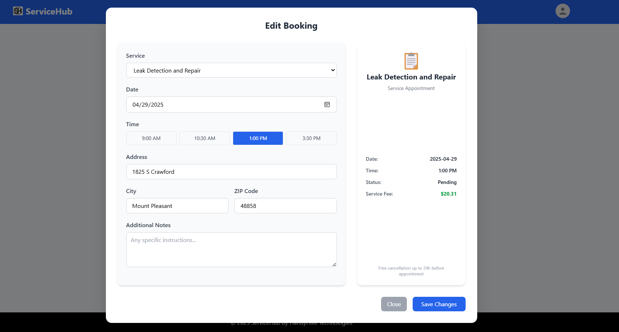

**My Bookings Page after Completing Appointment:**

After a service appointment is marked as completed, users are provided with the option to submit a review through the Write Review button. This feature allows customers to share feedback about their experience with the service provider.

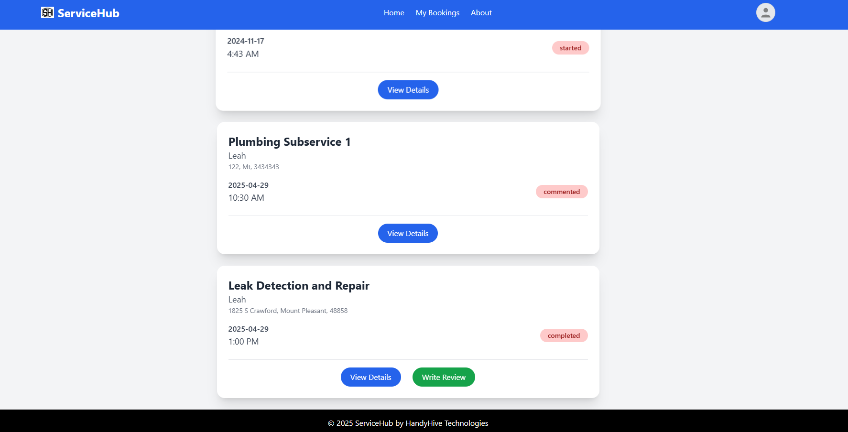

**Code For My Bookings Page and Edit Bookings:**

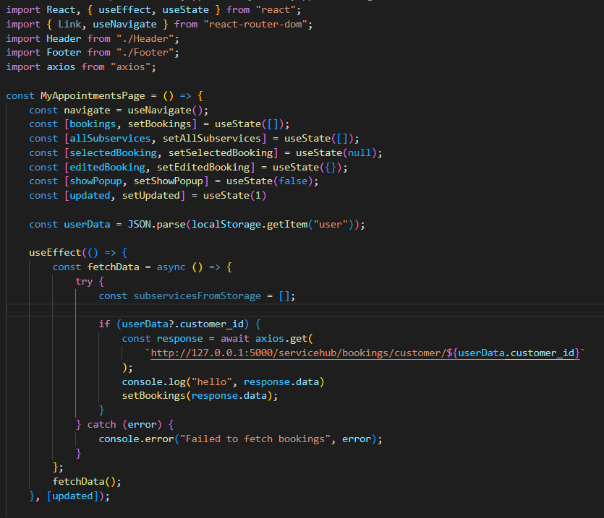

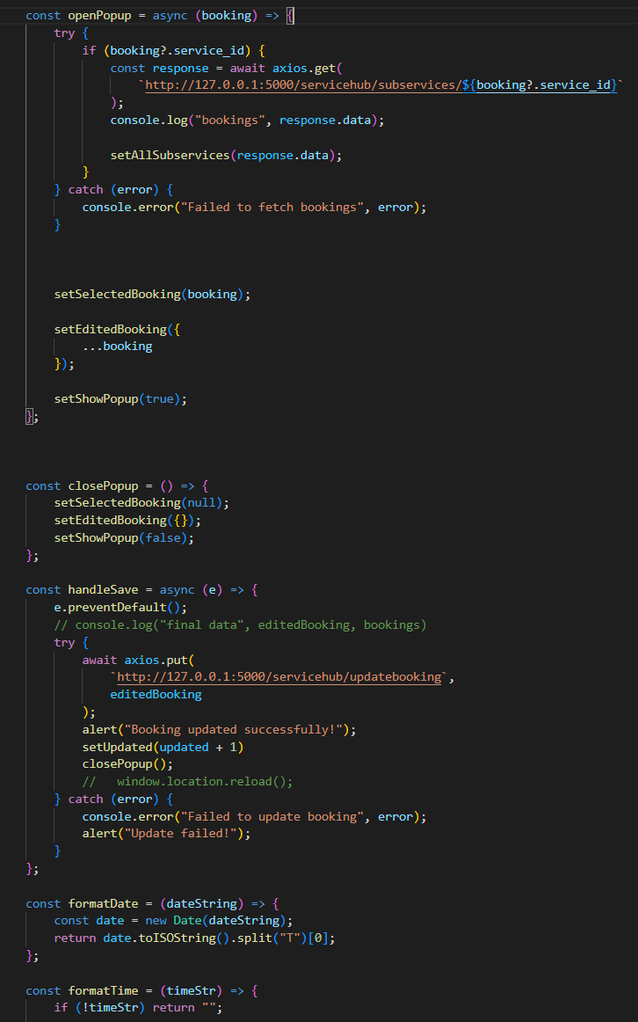

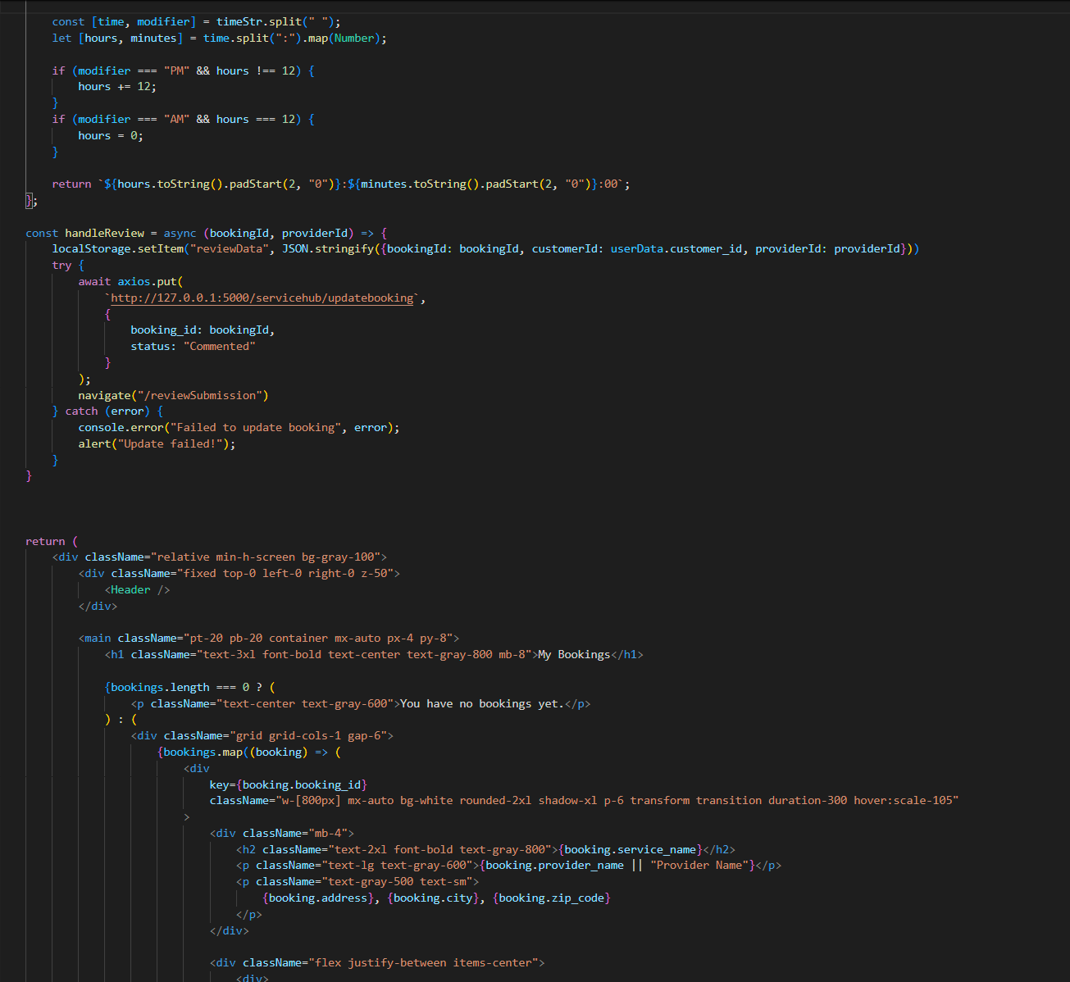

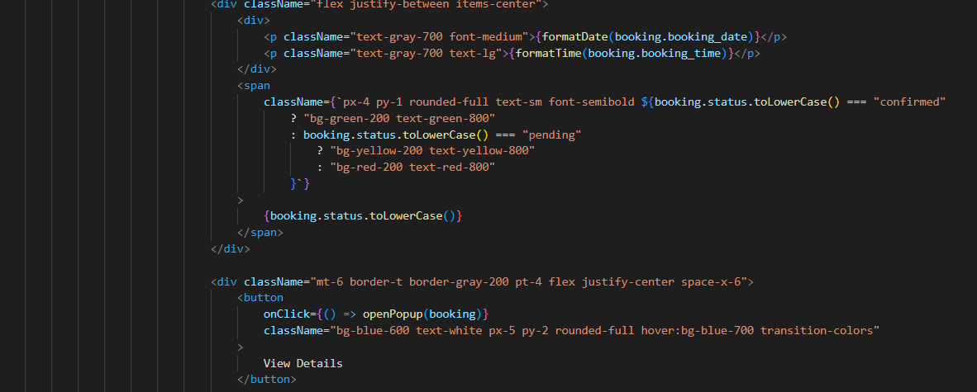

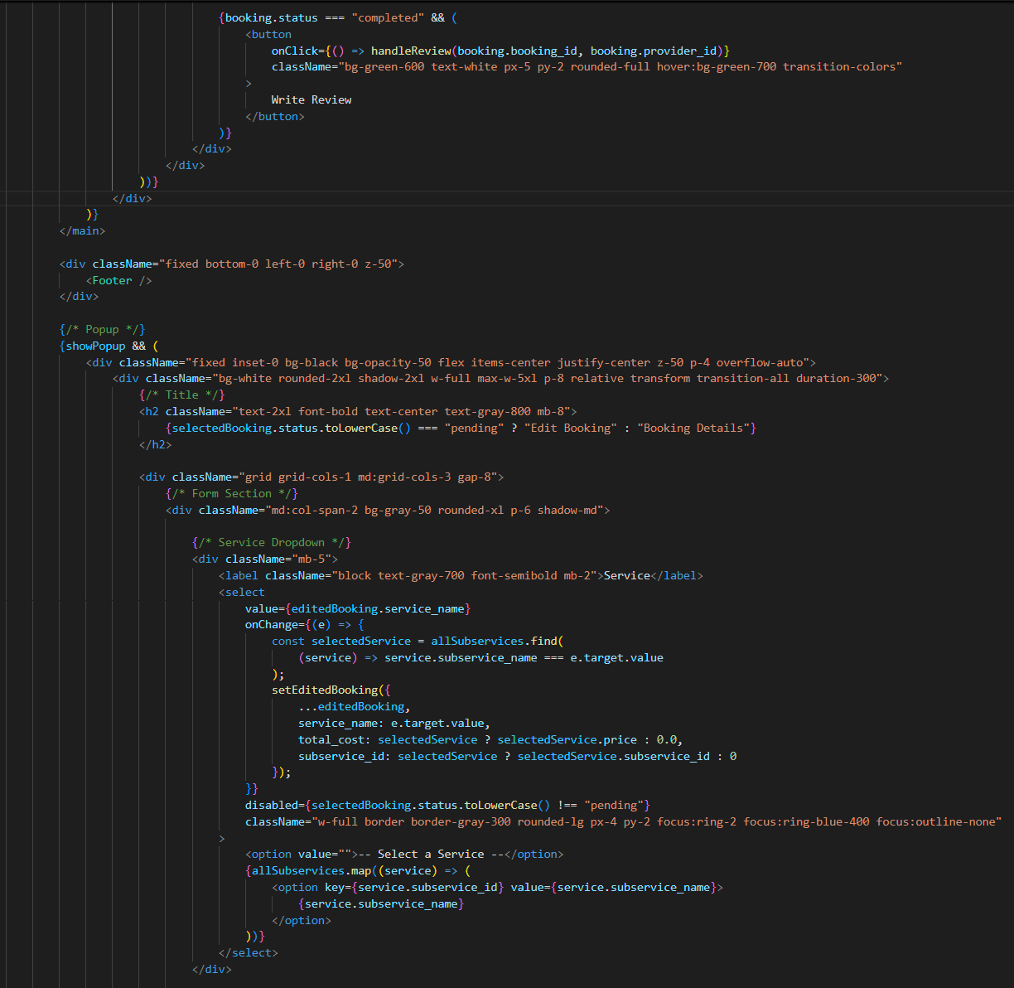

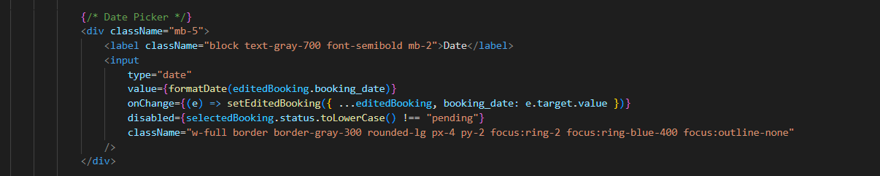

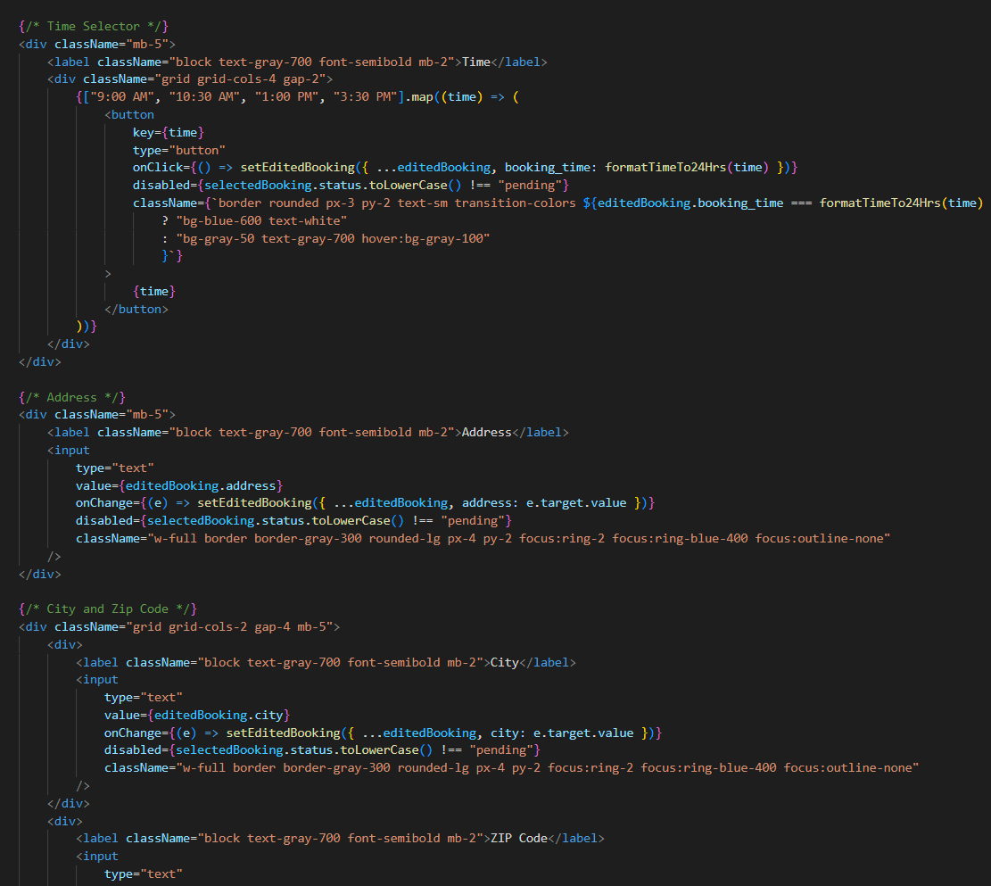

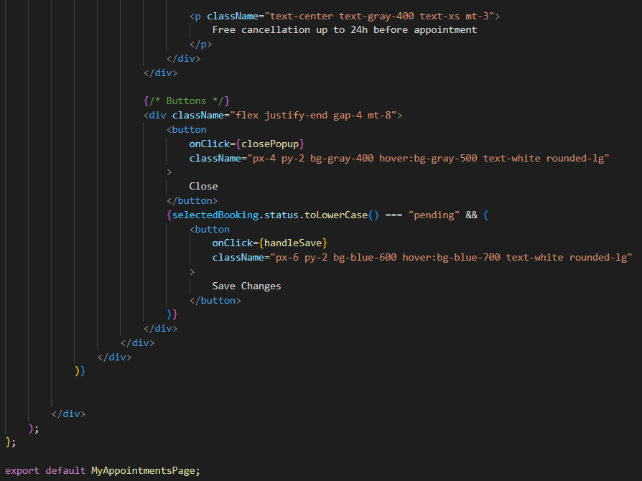

**Reviews Page:**

The Rate Your Experience page allows users to provide structured feedback after a service is completed. This helps maintain service quality, supports performance evaluation, and guides future customers in making informed decisions.

Steps to Use:

1. Select an overall star rating that reflects your experience.
2. Click on each circle to rate individual service aspects by category.
3. Enter your comments in the text area.
4. Click Submit Review to complete the feedback process.

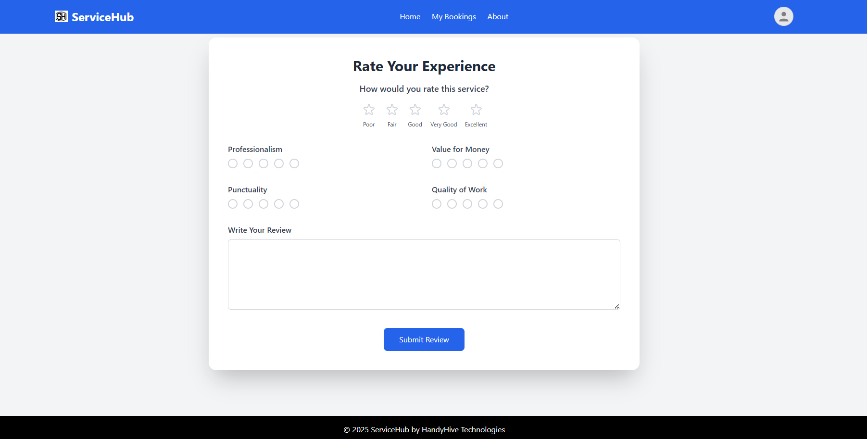

**Code:**

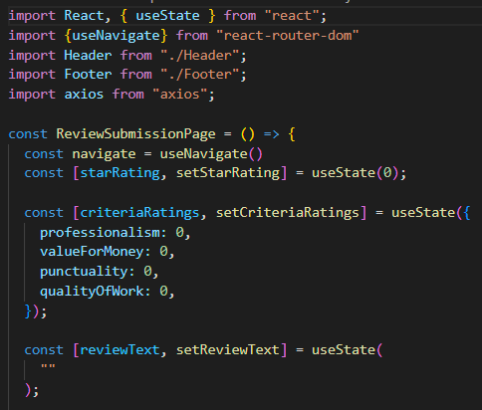

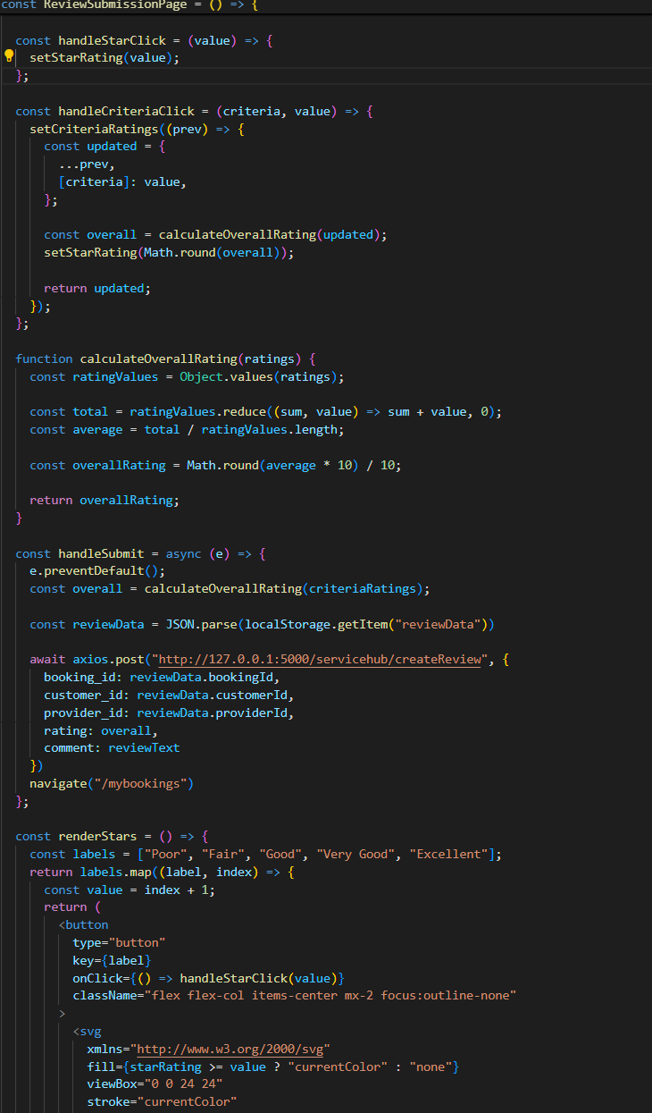

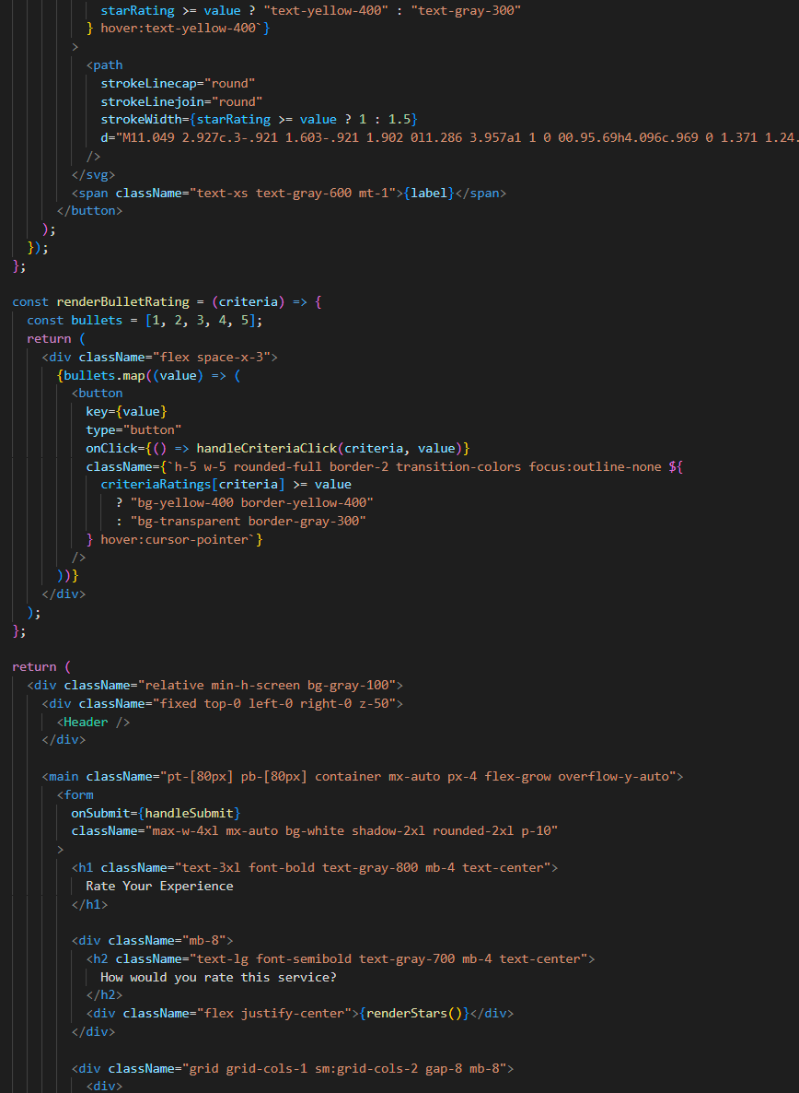

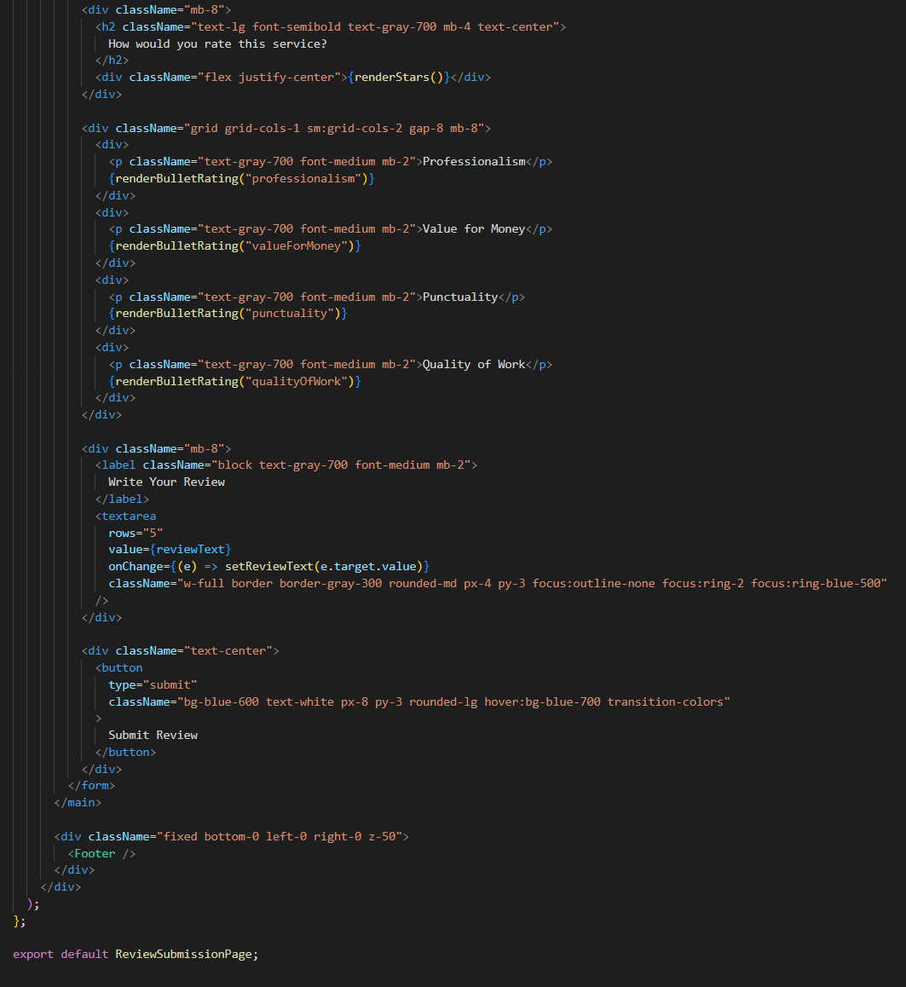

**Manage Profile:**

The Manage Your Profile page enables users to update their personal and account-related details, ensuring that their contact information and preferences remain accurate. When a user clicks on the profile button, this page is displayed.

**Steps to Use:**

1. Modify any editable field with your updated personal details.
2. Click Save Changes to apply and store the updates.
3. To end your session, click Logout.

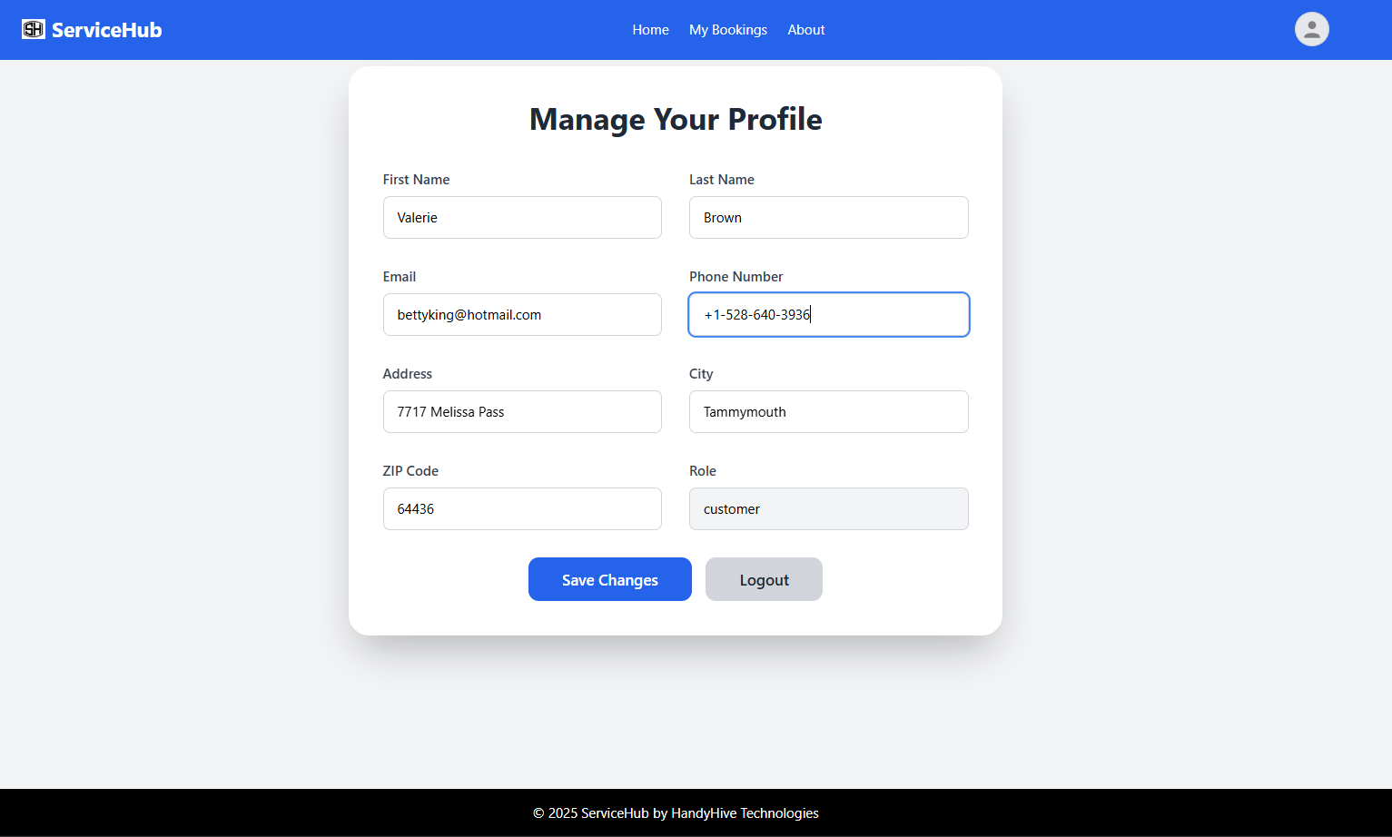

**Code:**

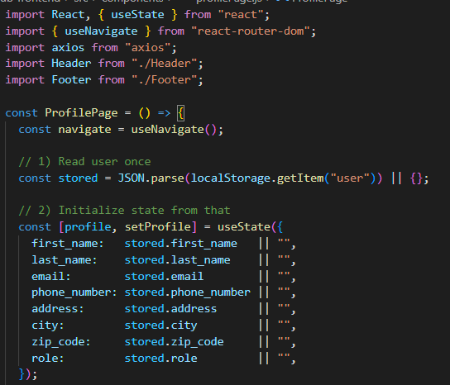

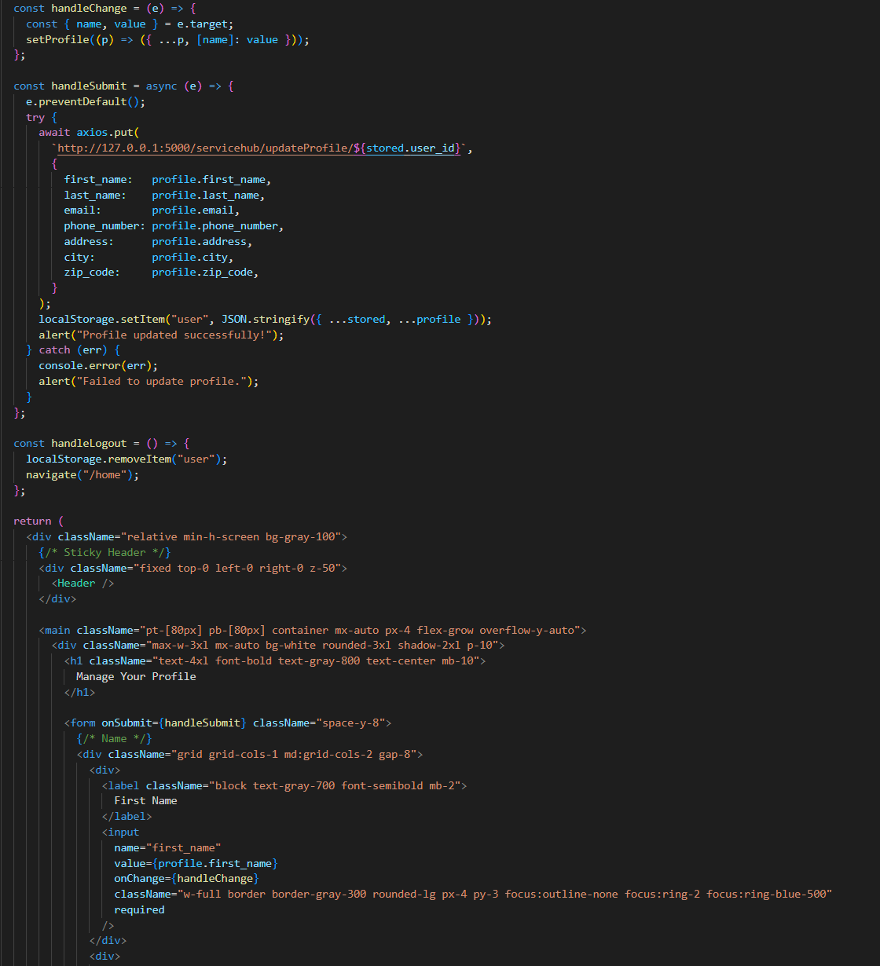

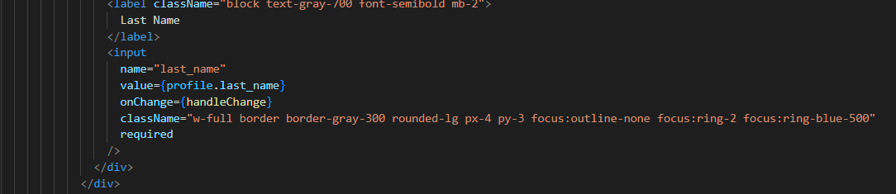

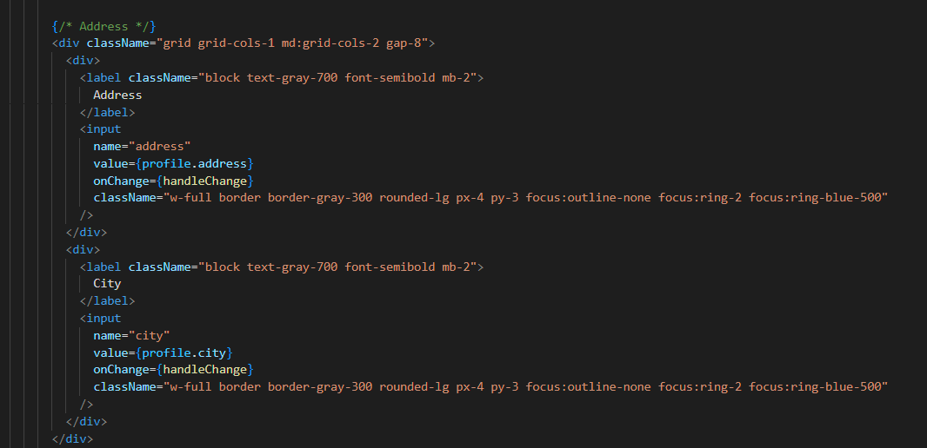

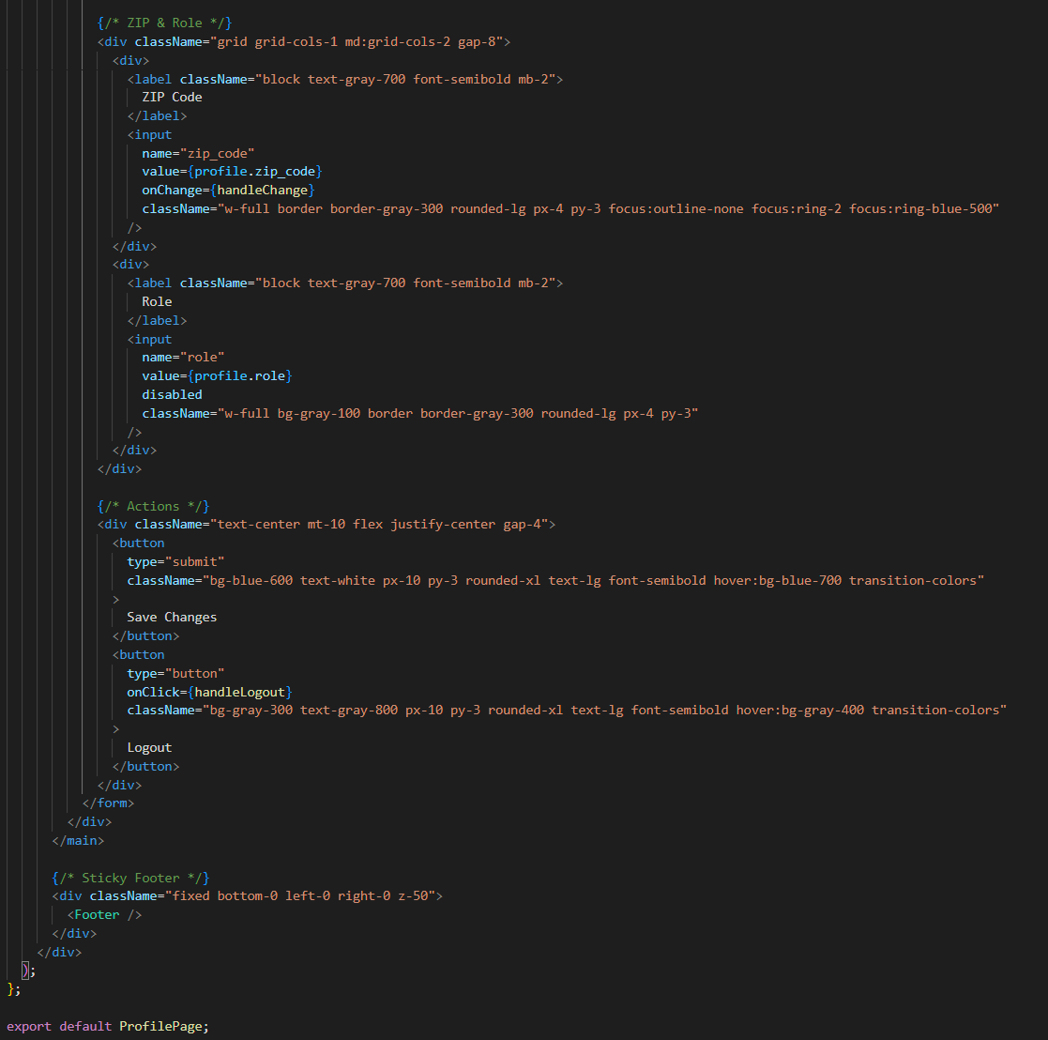

**Service Provider Interface**

**Provider Dashboard Page:**

The Provider Dashboard offers service providers a centralized view of their operations, including appointment tracking, service management, and ratings monitoring. The Appointments card prominently displays the total number of appointments scheduled for the current day, allowing providers to stay organized and plan their workday effectively.

Steps to Use:

1. Review your daily summary and overall performance.
2. Review the list of scheduled appointments and click Start to begin a service. The Start button becomes available for the next appointment only after the current service is completed.
3. Use the Manage Services button to update your availability or offered services.

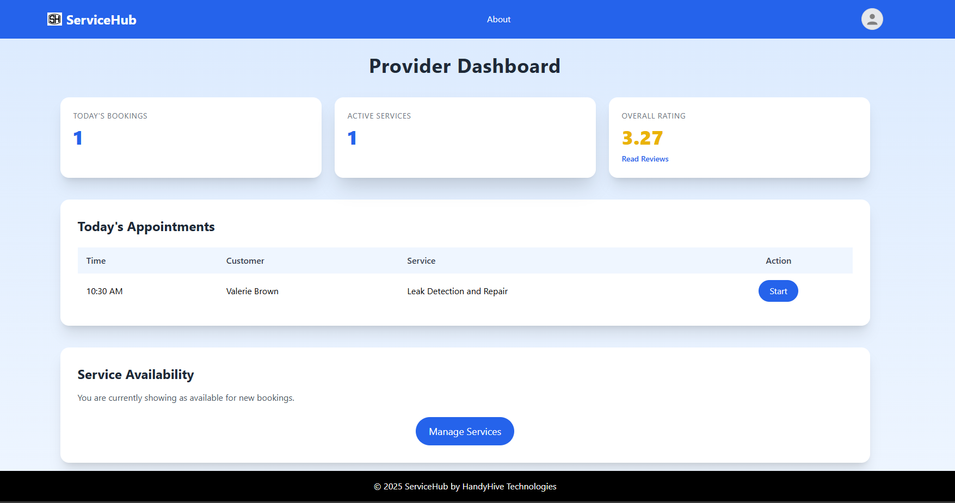

**Manages Services Pop Up Window:**

When a service provider clicks the Manage Services button on the Provider Dashboard, a pop-up window appears that allows them to manage their service listings. The interface includes options to add new services, new subservices, edit or remove existing ones, set pricing of the services, and update the overall service details. The changes can be saved by clicking the Update Service button or discarded by selecting Cancel. This functionality is essential for keeping service listings up-to-date and aligned with what the provider currently offers to customers.

Steps to Use the Manage Services Pop-Up

1. Click the Manage Services button on the Provider Dashboard.
2. To add a new service, enter the Service Name and a brief Description.
3. Use the Add Subservice button to add new subservice rows, and input the subservice names and corresponding prices.
4. To modify an existing service, select it from the Current Services panel and make the necessary updates.
5. Click Update Service to save your changes or Cancel to discard them.

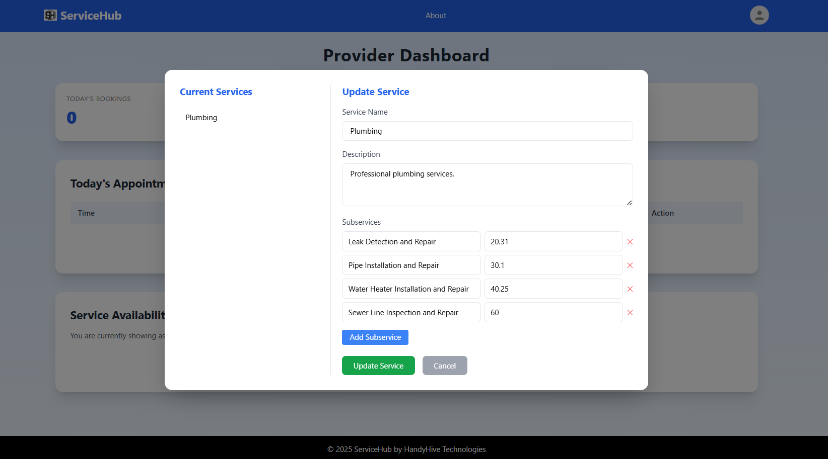

**Provider Dashboard and Manages Services Pop Up Window Code:**

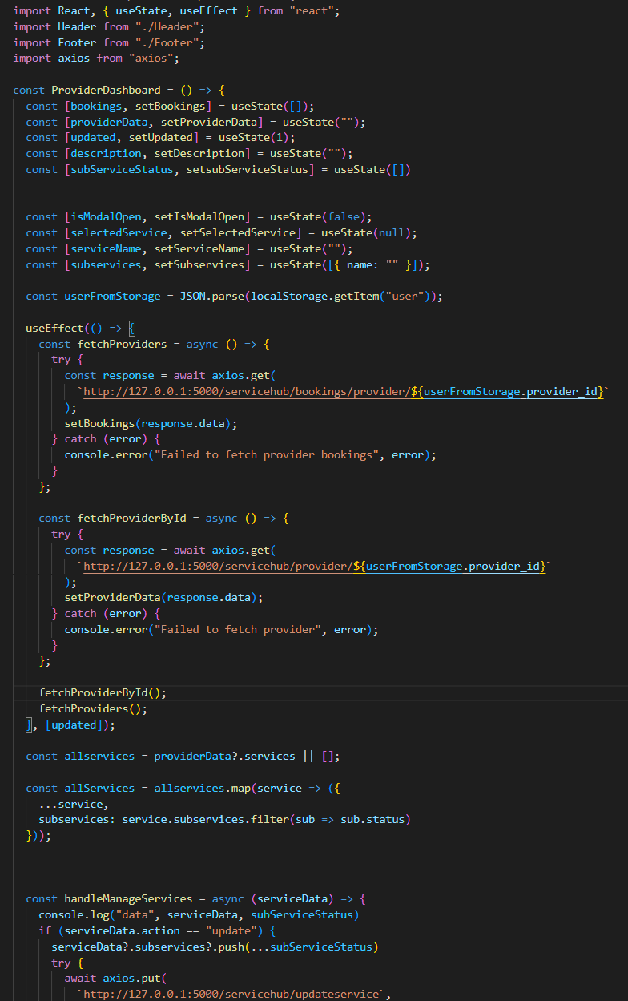

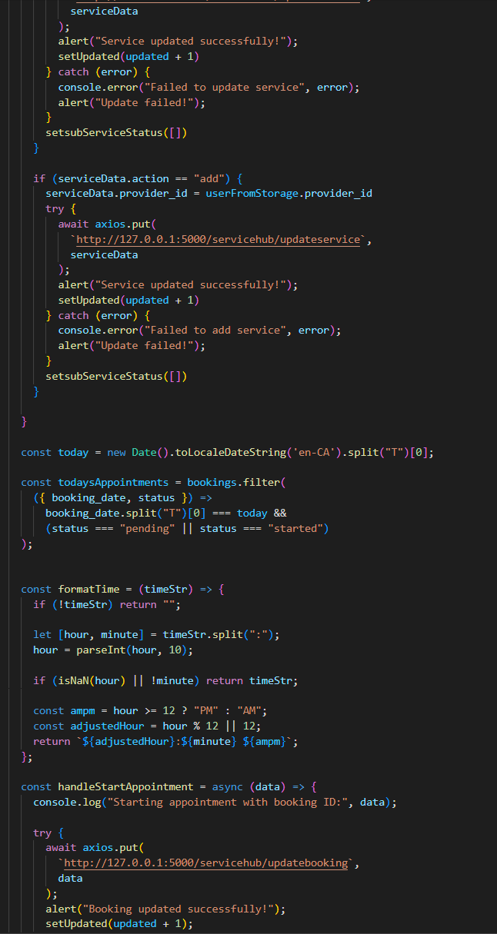

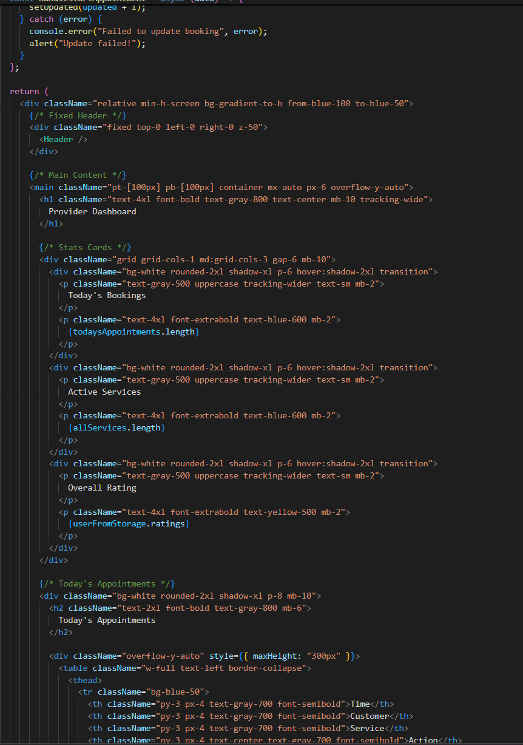

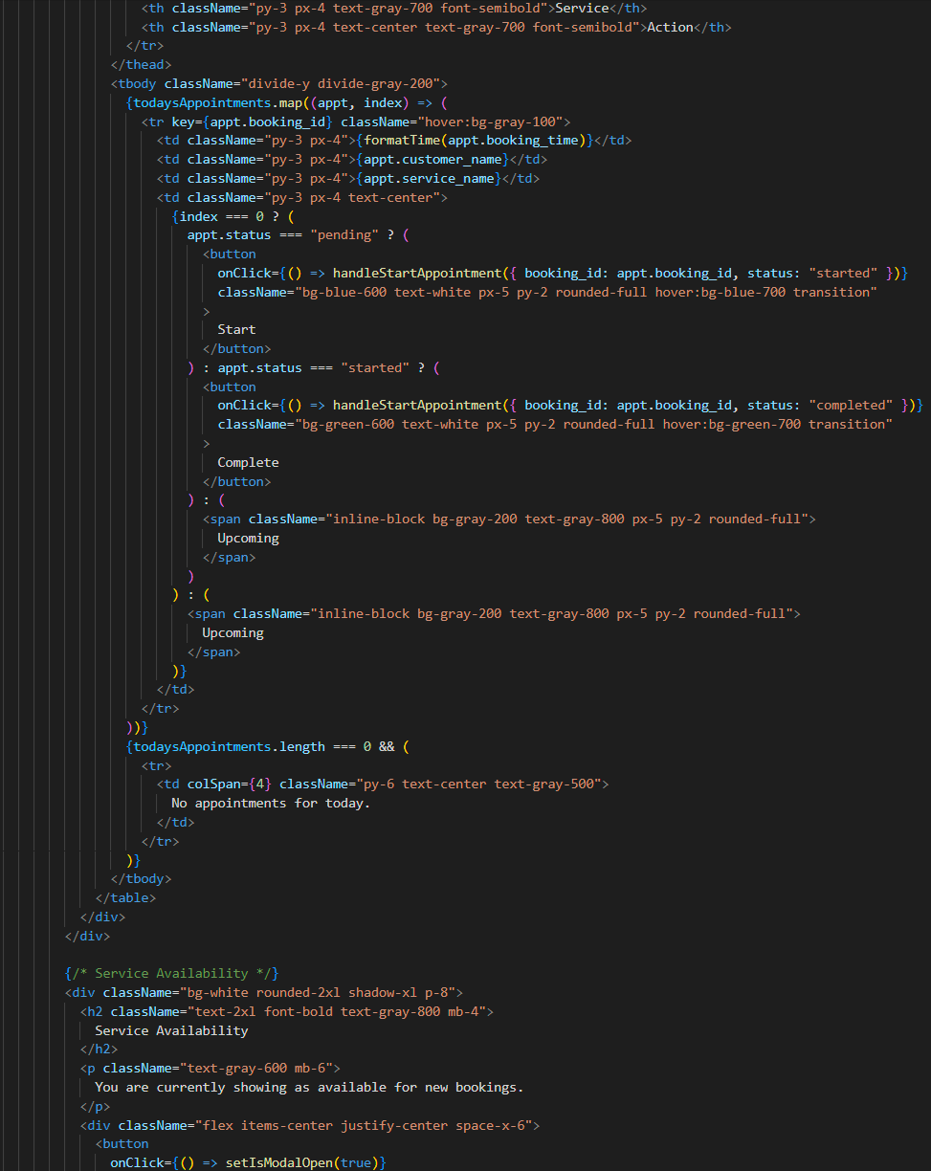

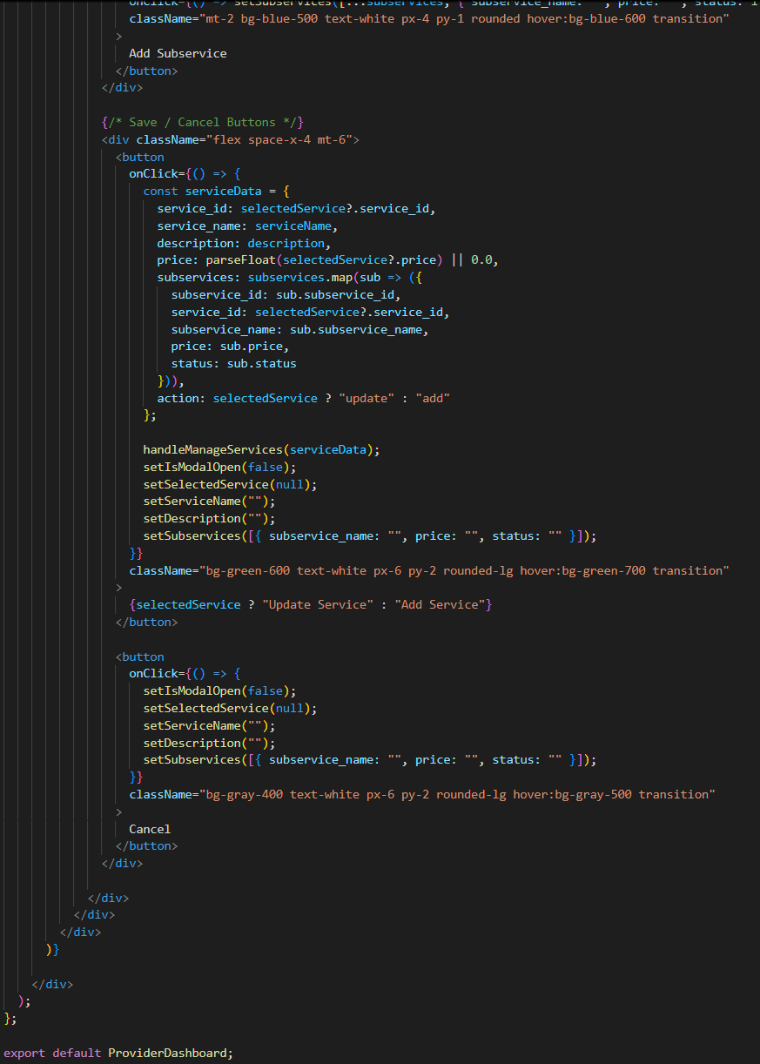

**Admin Interface**

**Admin Dashboard:**

The Admin Dashboard in Service Hub offers a consolidated view of recent bookings and service performance, helping administrators monitor activity and make informed decisions. It includes a recent bookings table, a performance chart by service type, and a link to view all bookings for detailed oversight.

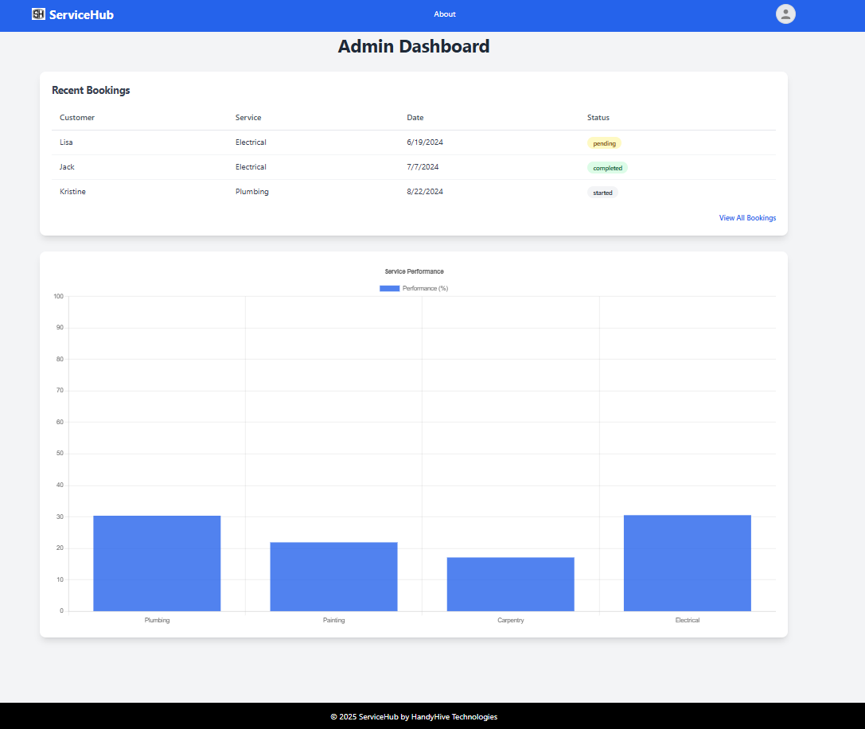

**View All Bookings Pop-up:**

When the administrator clicks the View All Bookings button, a detailed modal view is displayed, presenting a complete list of all bookings made on the platform. This includes key information such as the customer name, service type, booking date, and current status (e.g., pending, started, or completed), allowing the admin to monitor booking activity across the system efficiently.

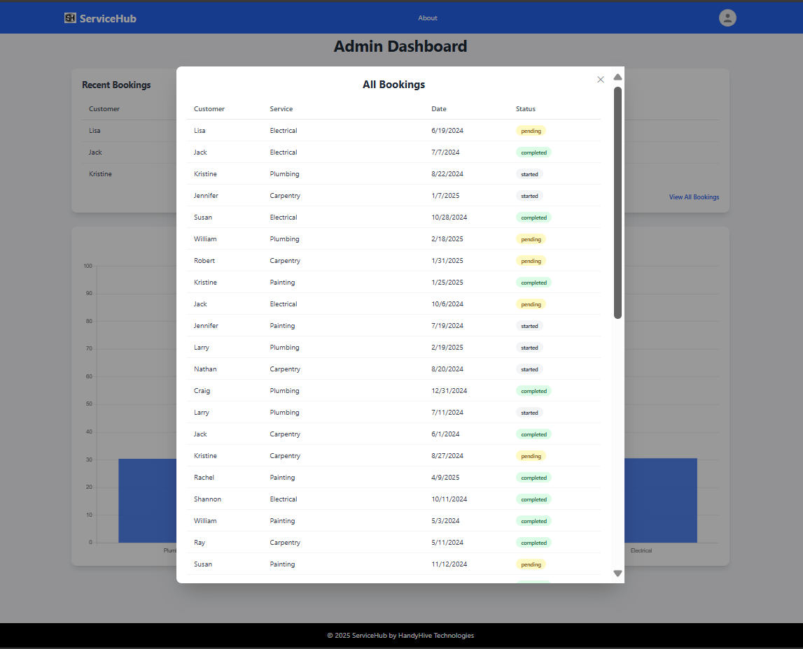

**Code:**

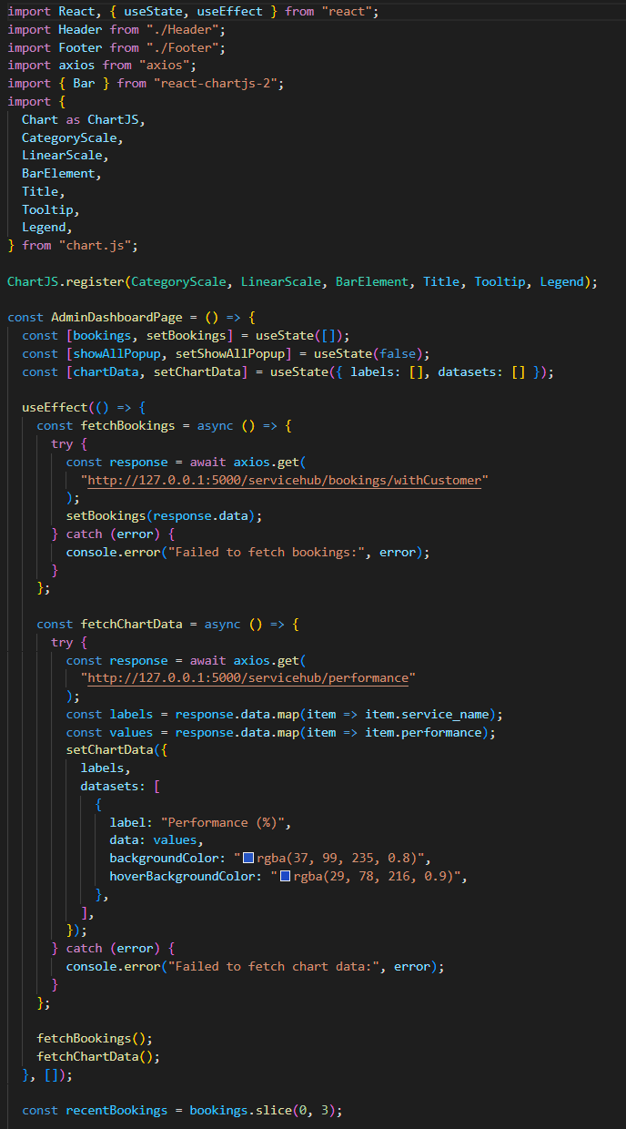

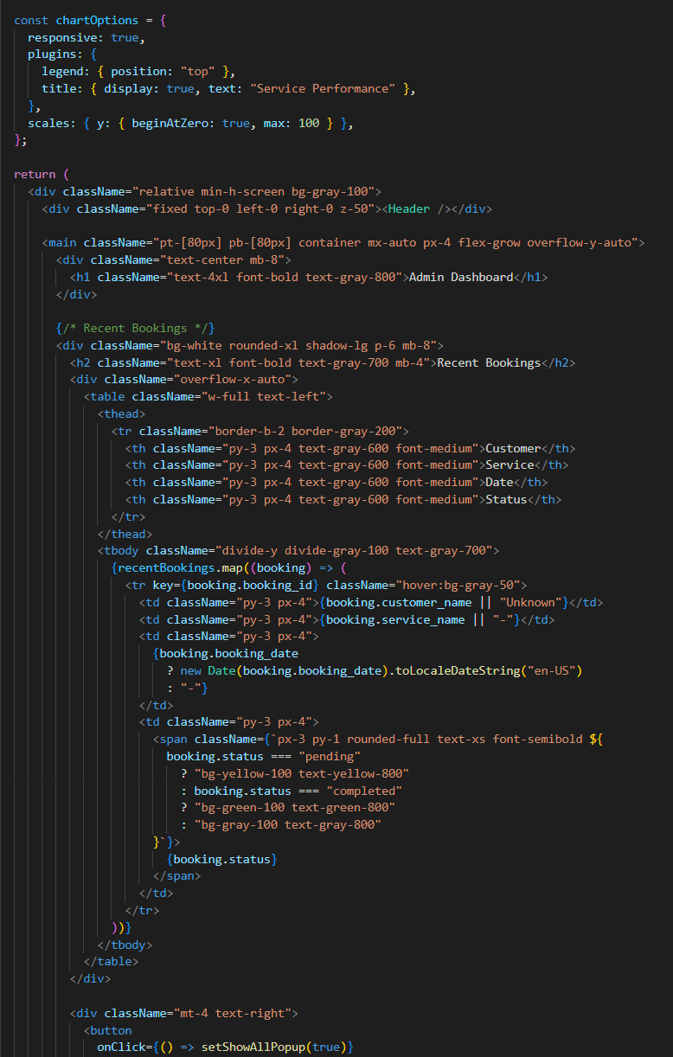

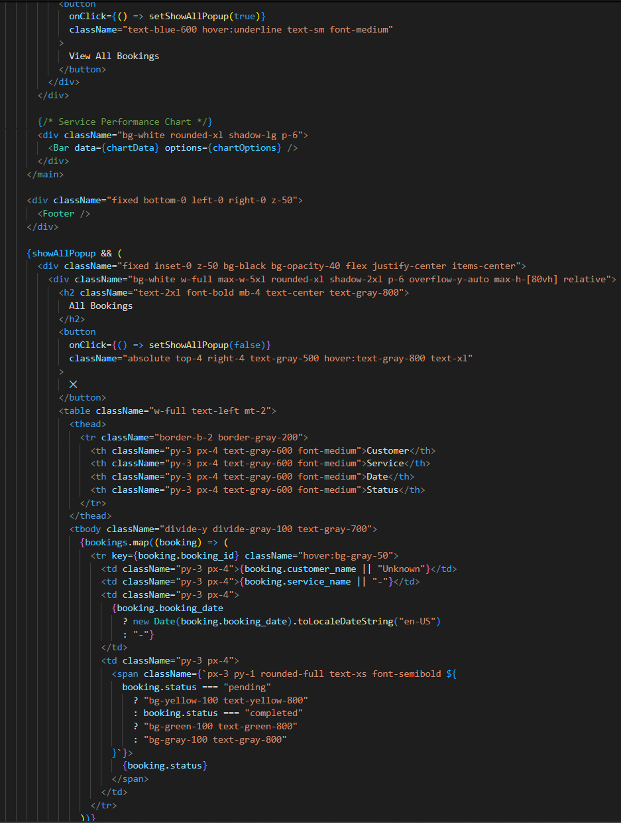

**About Page:**

This page gives a brief overview of the Service Hub platform, highlighting its purpose and core values. Service Hub is designed to bridge the gap between customers and local service providers by offering a reliable and efficient digital platform for booking services.

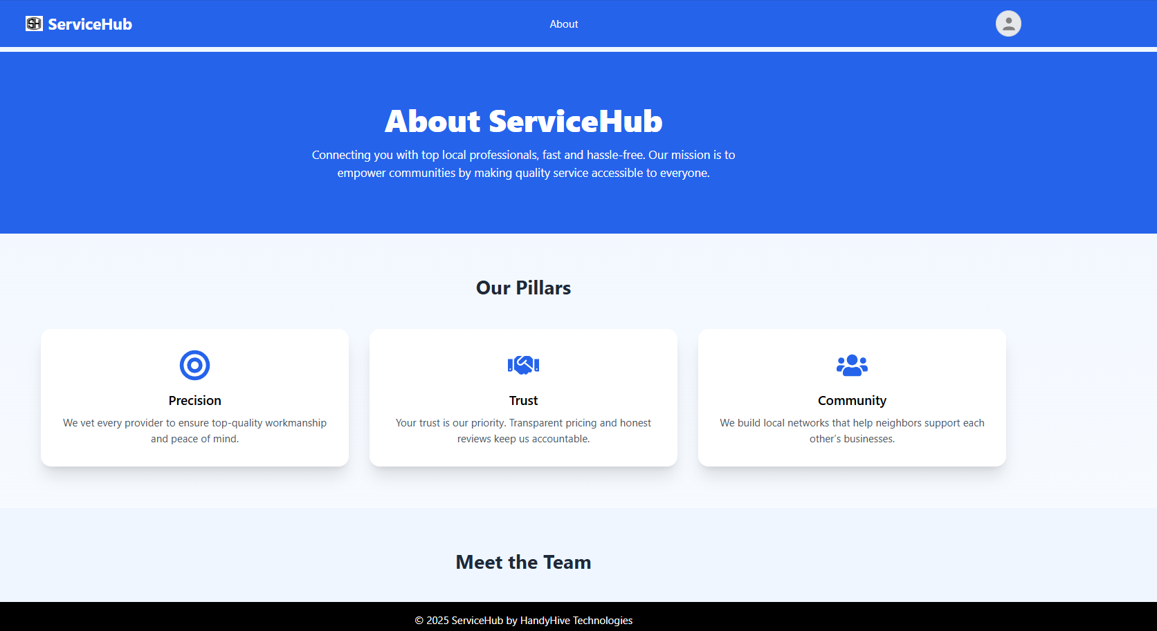

**Code:**

